Learner guide to "The Bridge”

This is a guide to help you navigate the Minecraft world “The Bridge”. In this document you will find the following (you can jump to the parts by clicking the title):
1. Background story of the world 1
2. Your building tasks in the game world 2
3. Your tasks outside of the game 4
4. Game mechanics and how to play 4
5. Rules 9
6. Summary 10
7. Help for communicating with others 11

1. Background story of the world
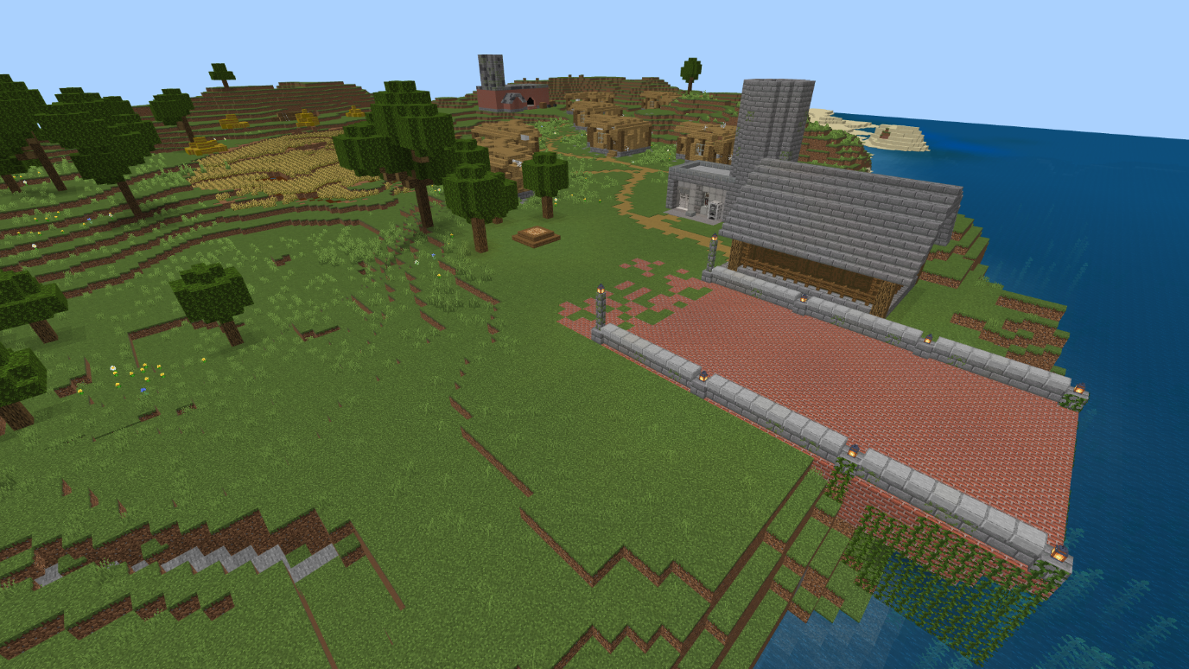

Welcome to the Minecraft world “The Bridge”! This world consists of an island, which is connected to the mainland by a bridge. The connection to the mainland has been severed due to a natural catastrophe caused by climate change. You are the inhabitants of the island, and you have to reconnect the two lands. At the moment, you are stuck on the island with no way of reaching the mainland. Your first task is to repair the bridge and restore the connection.

Your houses on the island are also very old and falling apart, especially due to the natural catastrophe. Additionally, they still contain some asbestos, which was used as insulation until the 1990s. Nowadays it is known to be very dangerous for health. There’s also an old coal factory, not anymore in use but still containing some coal and more asbestos. The catastrophe has damaged the factory, making it unstable and dangerous. You should also repair the houses and consider what to do with the old factory building.

There had also been plans for converting a part of the island into a protected natural reserve. The conversion project had already been started, but the work was interrupted because of the catastrophe. The protected area now needs to be marked with a fence/border/etc.

Because the island has been disconnected from the mainland, you won’t have unlimited materials at your disposal. This means that everything you use for building has to be found on the island or traded with the merchants. You should therefore make a good plan and see what kind of materials there are to be found.

2. Your building tasks in the game world

The island's main bridge to the mainland has broken and your first task is to repair it. This can be accomplished in a variety of ways, and you may use any materials that you want for this building process. You are given a map of the island, which shows the different materials that can be found on the island. You should, however, consider what materials make sense for building a bridge (for example, a bridge built from hay is probably not very strong nor fireproof). Once you have restored the connection between the island and the mainland, you will unlock new materials.

Due to the natural catastrophe the houses on the island have fallen into disrepair. Your task is also to remove the white asbestos found inside the houses and repair them at least to a usable degree. The asbestos can be disposed of by mining it and giving it to an NPC (non-player character) merchant, who will dispose of the asbestos safely and responsibly.

There is also an old factory which you can see in the background in the picture below. It is filled with coal and asbestos and you should remove these materials and bring them to an NPC merchant. You will get money in exchange for these materials, and you can use this money to buy different, perhaps more useful materials. There are different NPCs that can trade certain materials with you. As you remove the coal and asbestos, you should also think about the factory itself: it’s very damaged, but could the building be repurposed somehow?
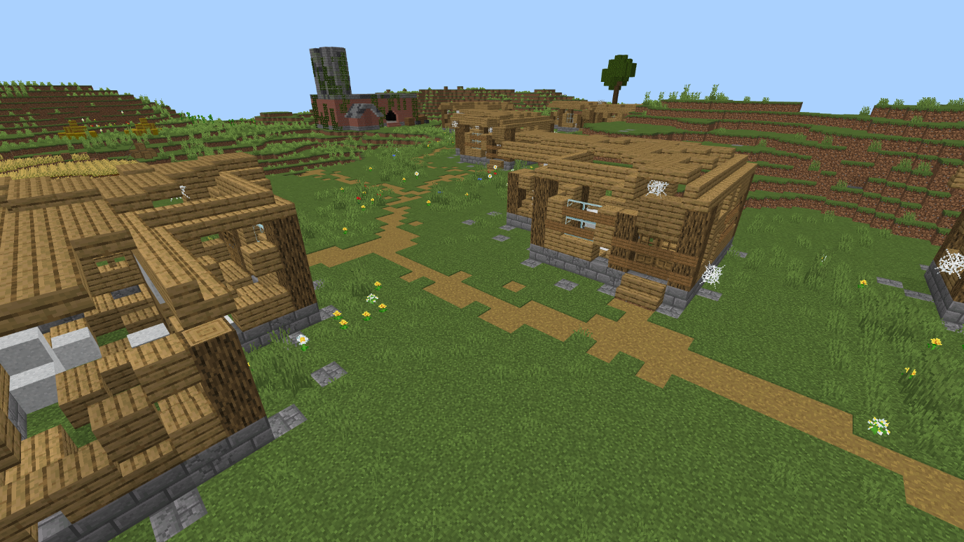

You are also given a map of the island, which shows the different materials you can find on the island. There’s also a green line drawn on the map: this shows the border for the planned nature reserve. You should build a fence/border/etc. to mark this line (as accurately as you can) in the game world. Note that since the trees behind the line are protected, you aren’t allowed to cut them down. The few trees that aren’t behind the line, you may utilize as material.
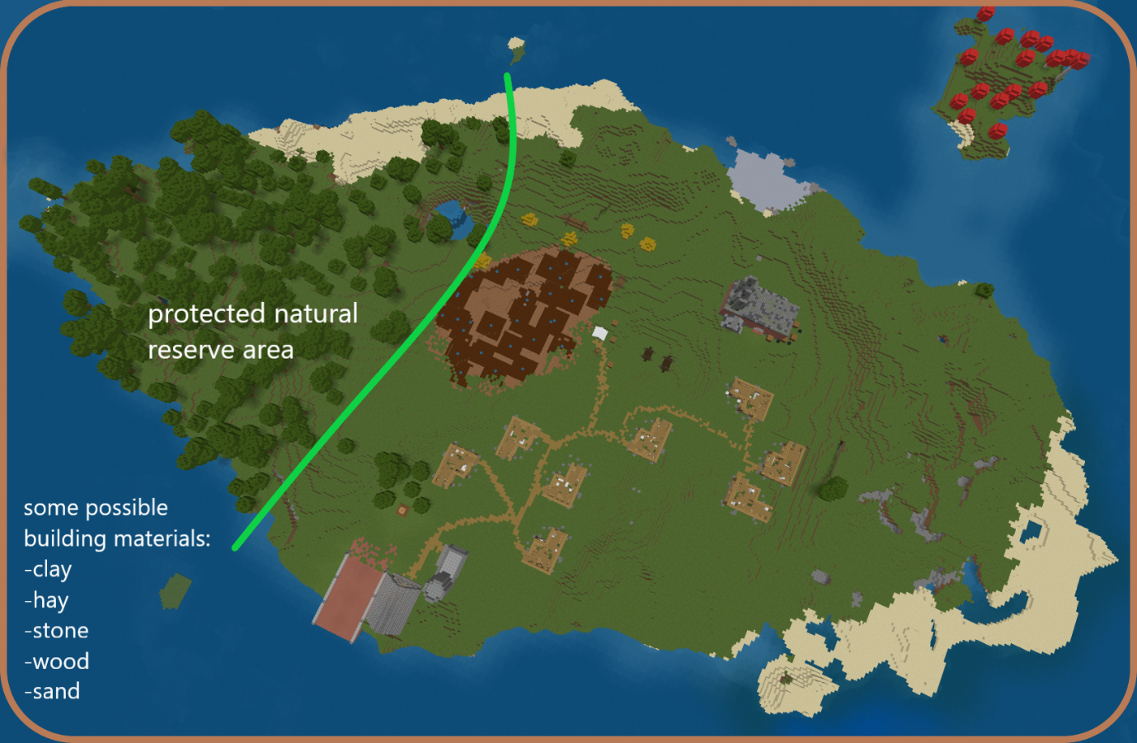

3. Your tasks outside of the game

While researching and building, you should discuss the challenges and different solutions together with your group. Because your resources are limited, you should plan well beforehand. Try to be creative as well: what materials might be useful for building? What can you make from things you find? Tip: if you’re unsure about a material, research real-life use cases for it online. Remember that it’s often easier to recycle than to make something from scratch.

At the end of the project, you should also present your thoughts and findings. Your teacher will give you details on whether it’s, for example, in the form of a group presentation or a written essay or a video project. Additionally, you should also reflect on your own learning: What did you learn? Was this type of project useful for you? How did you feel about working with others on this topic?

4. Game mechanics and how to play

In this world you won’t have an unlimited inventory of materials. Instead, everything you use must be found in the world or traded with the merchants. You will be given tools to make digging and mining quicker. When you reach the mainland, you can buy faster tools from a merchant.

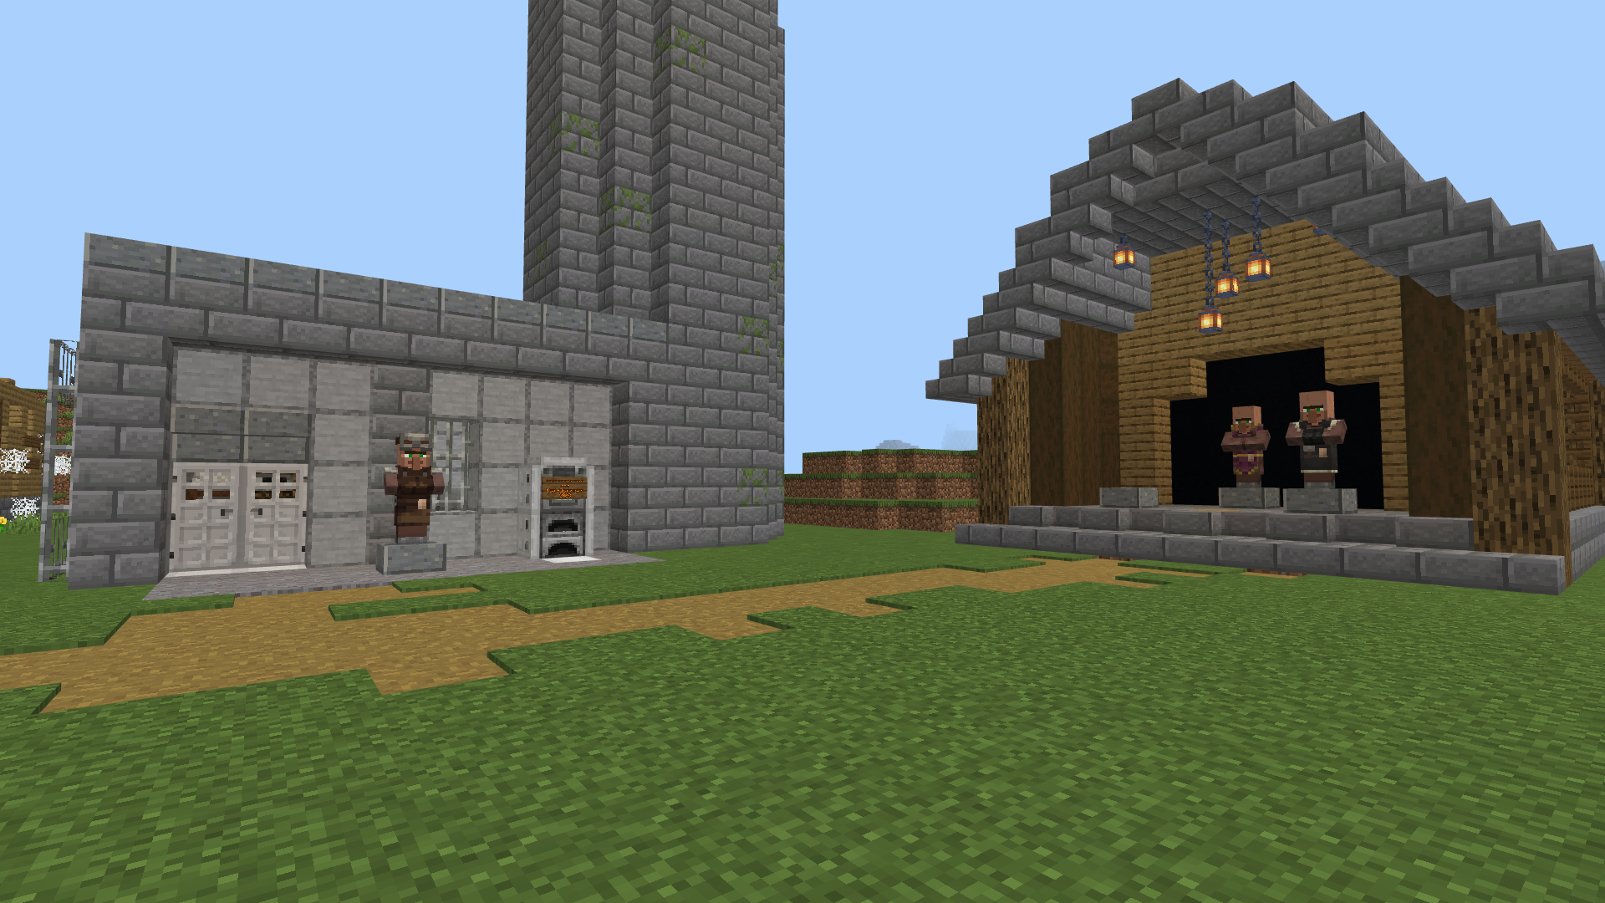
There are altogether 3 NPCs (non-player characters) by the bridge area who can trade certain materials. After you reach the mainland, you will unlock new merchants and materials.
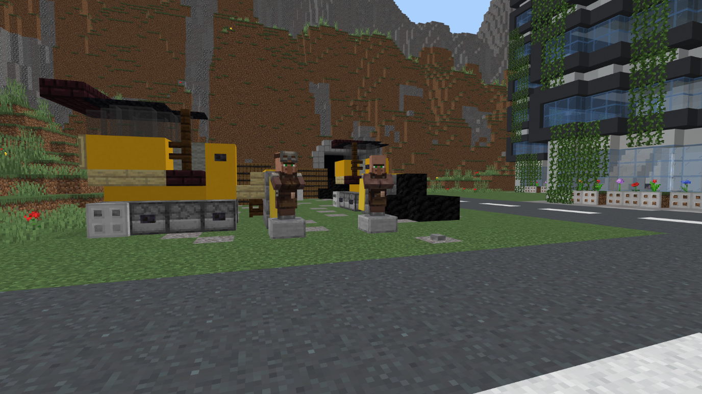
How to play
A separate guide will help you with installing the game on your computer and joining the game server. Once you are in the game on the Excalibur server, open text chat with T and write the following: /warp two_islands
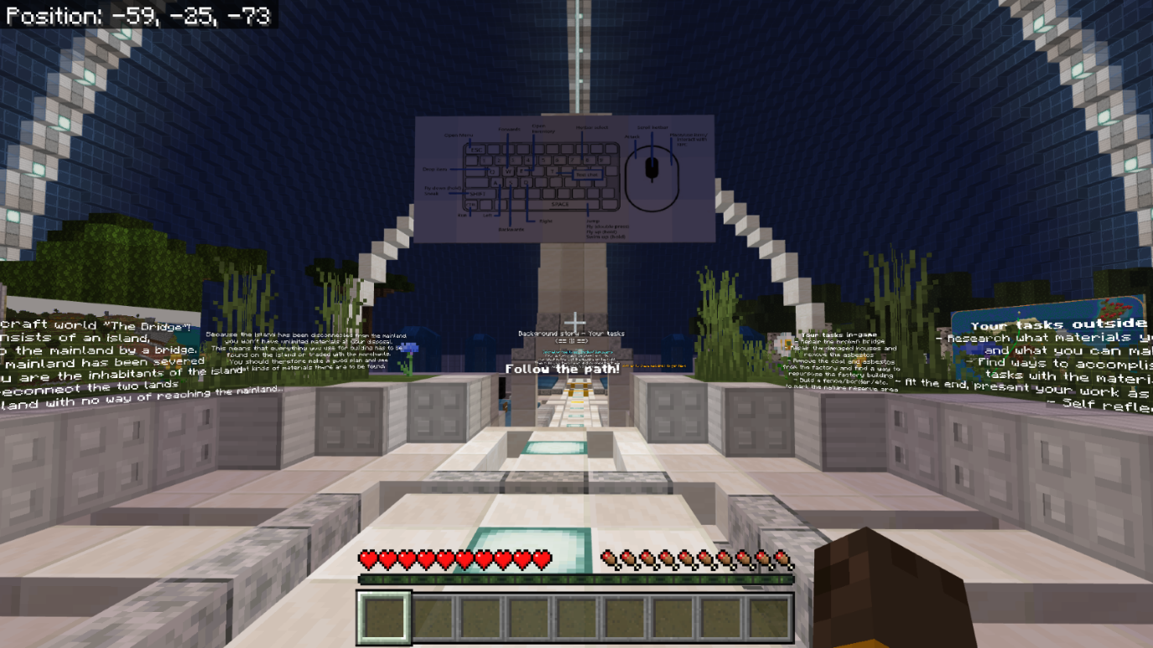
After that, press Enter and you will be transported to the correct game world. Once inside, you will first be guided through a small tutorial.
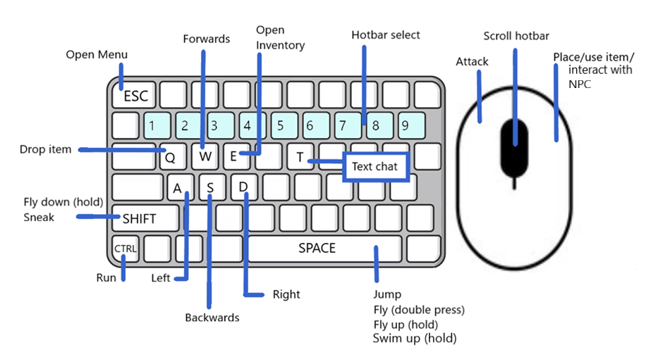
Once inside the game, use the W, A, S, D buttons to move and the mouse to look around. Press the space key to jump.
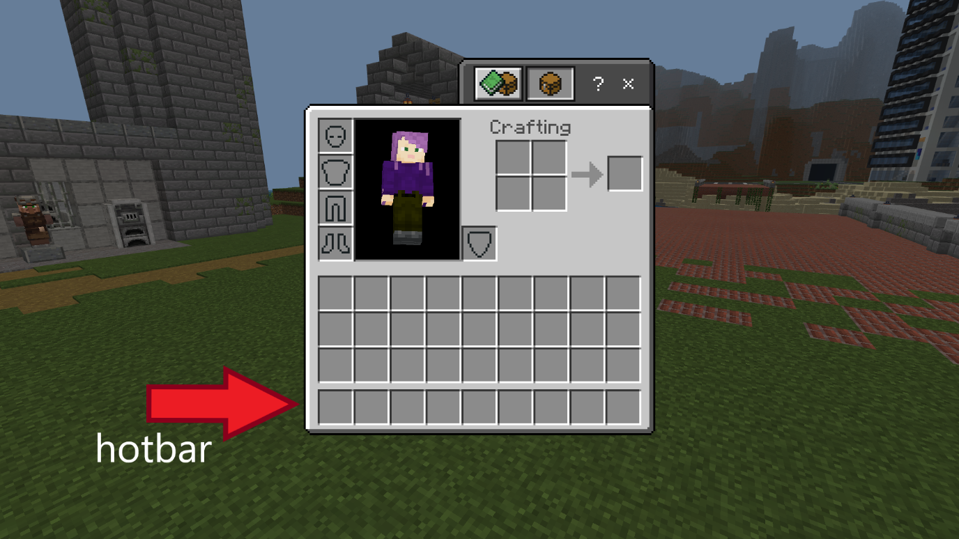
By pressing E, you can open your inventory. When you find a material, it will be added automatically to the lowermost row on the screen. This row is called the hotbar, and you can go through its contents using the number keys or the mouse scroll. When playing, you can access the materials in this row quickly without opening the inventory again. If your hotbar is full when you pick something up, new materials will be added to the upper inventory space, and you will need to open the inventory to access them.
You can destroy blocks with the left-side button on your mouse, and place blocks or talk to the NPCs using the right-side button. When holding a block in your hand, you can drop it to the ground with Q, for example for others to pick it up. To collect a block from the ground, just walk towards it.
Open the text chat with T and press Enter to send your messages.
In this world you are also able to fly. To activate flight mode, press the jumping button (space key) two times quickly. By holding the space key after this, you can rise higher. Going lower happens from holding the shift key. Quickly pressing the space key twice will deactivate the flight mode. If you fall in the water, holding the space key will also let you swim upwards.
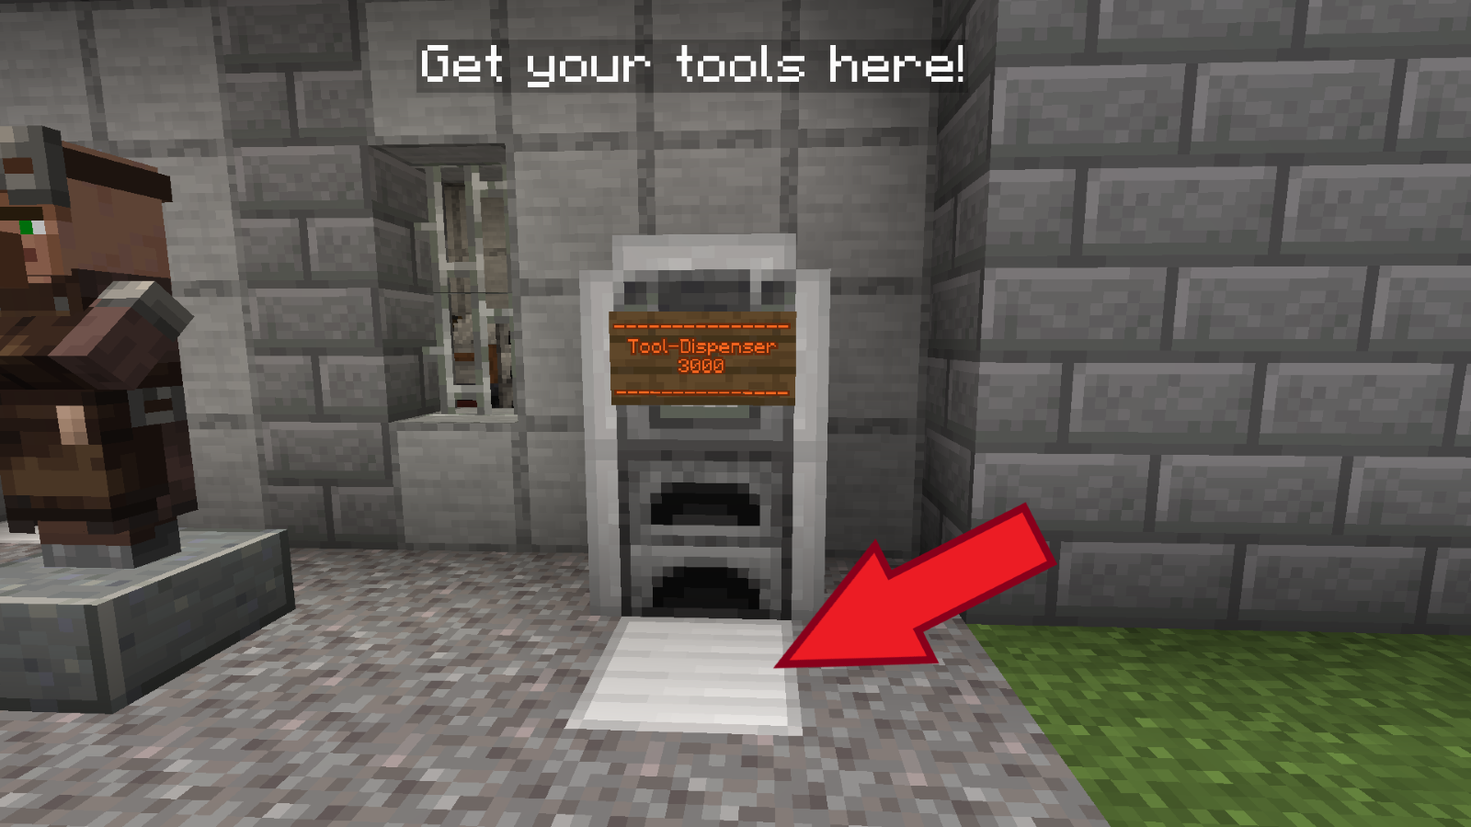
The mainland cannot be reached by flying.
You can destroy blocks faster using tools. You can obtain tools by the bridge area (picture above). Step on the gray plate and a set of tools will be added to your inventory, containing: an axe, a pickaxe, a shovel, a sword and a book of tasks. The book will have a short summary of your tasks, you can read it at any time by right clicking the book when it’s in your currently active hotbar slot.
After reaching the mainland, you can buy faster tools from a merchant. Different tools work better on different materials:

Tool | Shovel | Sword | Pickaxe | Axe
Works best on | Dirt, sand, asbestos | Cobwebs | Stone and metal | Wood

Trading
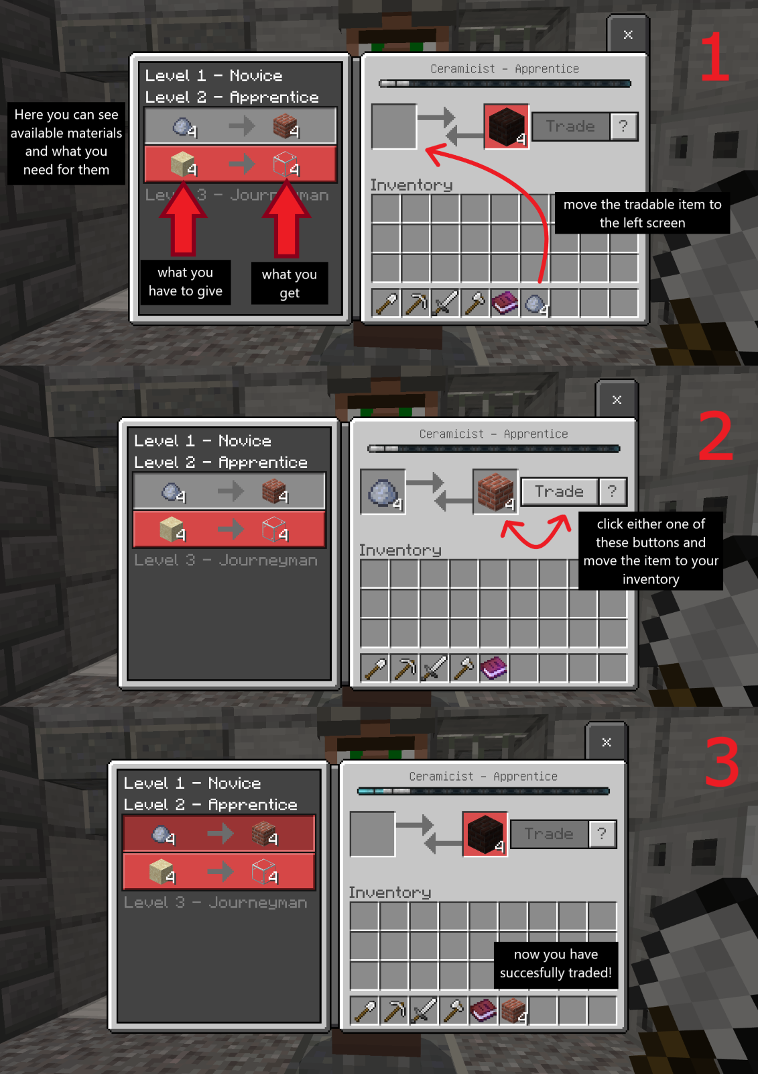
When you want to trade materials with the merchants, go to one and right-click them. It will open a trading screen, see the picture below.

5. Rules

1. Don't share the world address with any outsiders, nor the Minecraft account information (that you get) with anyone else.
2. Behave responsibly and in accordance with your school rules. Don’t destroy buildings built by other participants! Don’t disturb, harm or grief others or their building work.
3. Don't offend or insult anybody on purpose.
4. We are here to learn and grow together so make the experience enjoyable for everybody involved.

6. Summary
Your tasks in-game | Your tasks outside of the game
- repair the broken bridge | - research what materials you find on the island and what you can make with them
- repair the damaged houses and remove the asbestos | - find ways to accomplish your in-game tasks with the materials you have
- remove the coal and asbestos from the factory, find a way to repurpose the factory building | - at the end, present your work as instructed by your teacher
- build a fence/border/etc. to mark the nature reserve area | - self-reflection
- work and discuss together with your group

Controls to the game

7. Help for communicating with others

Vocabulary for “The Bridge”
More terms: https://minecraft.fandom.com/wiki/Minecraft_Wiki

You can add more terms/languages as needed!

Tools – Werkzeuge
 | English | Deutsch
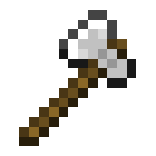 | an axe, axes | die Axt, die Äxte
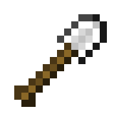 | a shovel, shovels | die Schaufel, die Schaufeln
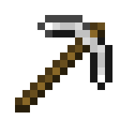 | a pickaxe, pickaxes | die Spitzhacke, die Spitzhacken
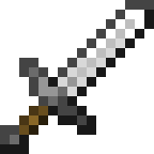 | a sword, swords | das Schwert, die Schwerter

Raw materials/Nature blocks – Rohstoffe/Naturblöcke
 | English | Deutsch
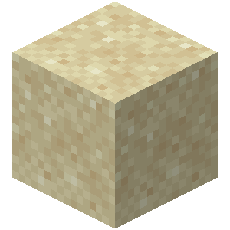 | sand | der Sand
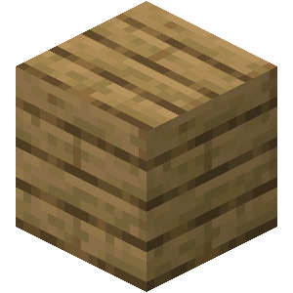 | wood/  planks | das Holz/  die Bretter
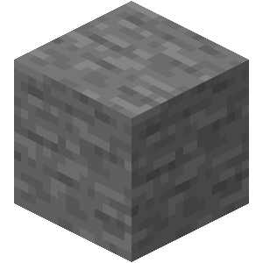 | stone | der Stein
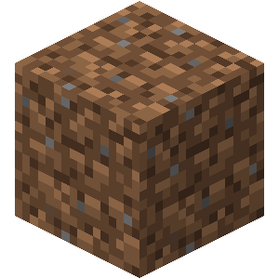 | dirt | die Erde
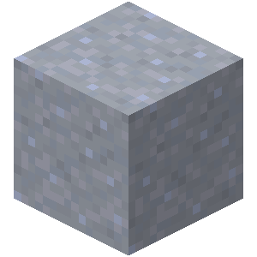 | clay | der Ton
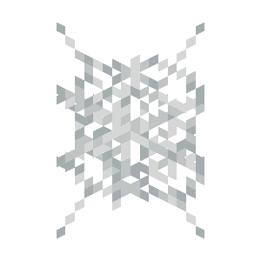 | cobweb | das Spinnennetz
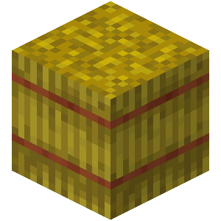 | hay bale | der Strohballen

Craftable/Tradable blocks – Herstellbare/Handelbare Blöcke
 | English | Deutsch
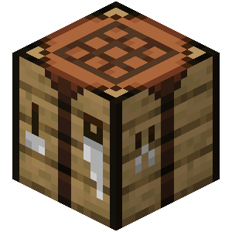 | a crafting table | die Werkbank, die Werkbänke
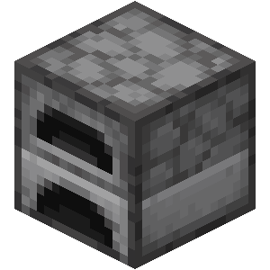 | a furnace | der Ofen, die Öfen
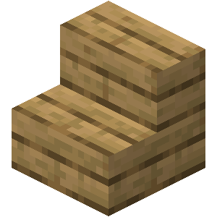 | stairs | die Treppe, die Treppen
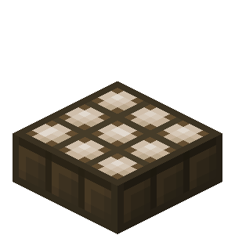 | solar panel, solar panels | das Solarpanel, die Solarpanels
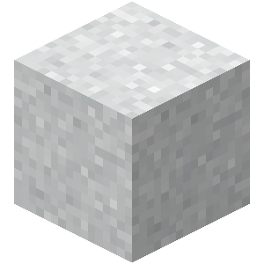 | asbestos | der Asbest
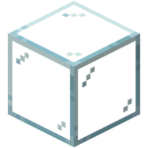 | glass | das Glas
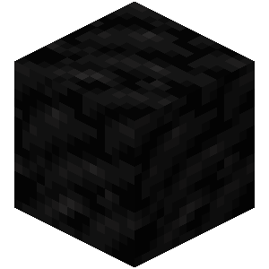 | coal | die Kohle
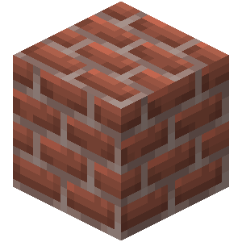 | bricks | die Ziegelsteine

Building verbs – Bauverben
English | Deutsch
dig, dug | graben, gräbt, grub, hat gegraben
mine, mined | ab/bauen, baut ab, baute ab, hat abgebaut
place (a block), placed | stellen, stellt, stellte, hat gestellt /  platzieren, platziert, platzierte, hat platziert
build, built | bauen, baut, baute, hat gebaut
destroy, destroyed | zerstören, zerstört, zerstörte, hat zerstört
pile, piled / stack, stacked | stapeln, stapelt, stapelte, hat gestapelt
put, put /  lay, laid, lain | legen, legt, legte, hat gelegt

Other verbs – Andere Verben
English | Deutsch
teleport, teleported | teleportieren, teleportiert, teleportierte, hat teleportiert
fly, flew, flown | fliegen, fliegt, flog, ist geflogen
die, died | sterben, stirbt, starb, ist gestorben
spawn, spawned | spawnen, spawnt, spawnte, ist gespawnt
swim, swam, swum | schwimmen, schwimmt, schwamm, ist geschwommen
jump, jumped | springen, springt, sprang, ist gesprungen
run, ran, run | rennen, rennt, rannte, ist gerannt
trade, traded | handeln, handelt, handelte, hat gehandelt
exchange X for Y, exchanged | X gegen Y tauschen, tauscht, tauschte, hat getauscht

Phrases – Phrasen
English | Deutsch
Opinion | Meinung
What do you think? | Was denkst du?
In my opinion ... | Nach meiner Meinung ...
I think that ... | Ich glaube, dass ...
Communication | Kommunikation
Could you explain with other words please? | Könntest du bitte mit anderen Worten erklären?
Could you repeat please? | Könntest du bitte wiederholen?
I’ll write/I’m writing in the chat | Ich schreibe in den Chat/im Chat
I don’t understand | Ich verstehe nicht
What are you doing/building? | Was machst/baust du?
Help/Problems | Hilfe/Probleme
Could you help me? | Könntest du mir helfen?
Do you need help with ...? | Brauchst du Hilfe mit ...?
I am stuck, please help | Ich bin stecken geblieben, hilfe bitte
I can’t find ... | Ich finde ... nicht
How can I ... | Wie kann ich ...
How can I build ...? | Wie kann ich ... bauen?
How do I use ...? | Wie benutze ich ...?
How can I find ...? | Wie finde ich ...?

