Learner guide to "The Flood”

This is a guide to help you navigate the Minecraft world “The Flood”. In this document you will find the following (you can jump to the parts by clicking the title):

1. Background story of the world 1
2. Your tasks in the game world 1
3. Your tasks outside of the game 2
4. Game mechanics and how to play 2
5. Rules 5
6. Summary 6
7. Help for communicating with others 6

1. Background story of the world
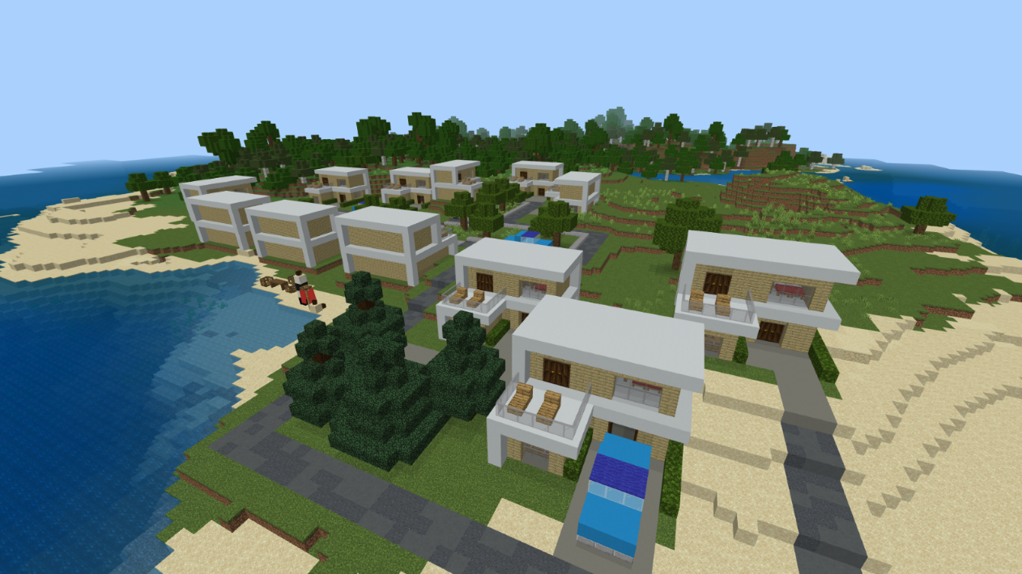

Welcome to the Minecraft world “The Flood”! Here you will find yourself living on an island with some houses and a small forest. You have been living on this island for a long time in harmony with your surroundings. However, due to climate change, your lives are threatened by the rise of the sea level. The current houses aren’t designed to hold water for very long and therefore you are in urgent need of new, ecological housing that will allow you to continue living on the island. You have to work quickly, though, because the sea level can rise at any moment!

2. Your tasks in the game world

Your task as a group is to build ecological and sustainable housing for yourself on the island, so that you can continue living there. Research different types of ecological building materials and techniques and decide what kind of house(s) you want to build. The sea level in the game will rise 4 block heights in total, so you have to ensure that your buildings don’t end up underwater in the end.

3. Your tasks outside of the game

While researching and building, you should discuss the challenges and different solutions together with your group. Try to decide what kind of solutions would be best in the long run. What if the water level rises even more in the future?

At the end of the project, you will also present your thoughts and findings. Your teacher will give you details on whether it’s, for example, in the form of a group presentation or a written essay or a video project. Additionally, you should also reflect on your own learning: What did you learn? Was this type of project useful for you? How did you feel about working with others on this topic?

4. Game mechanics and how to play

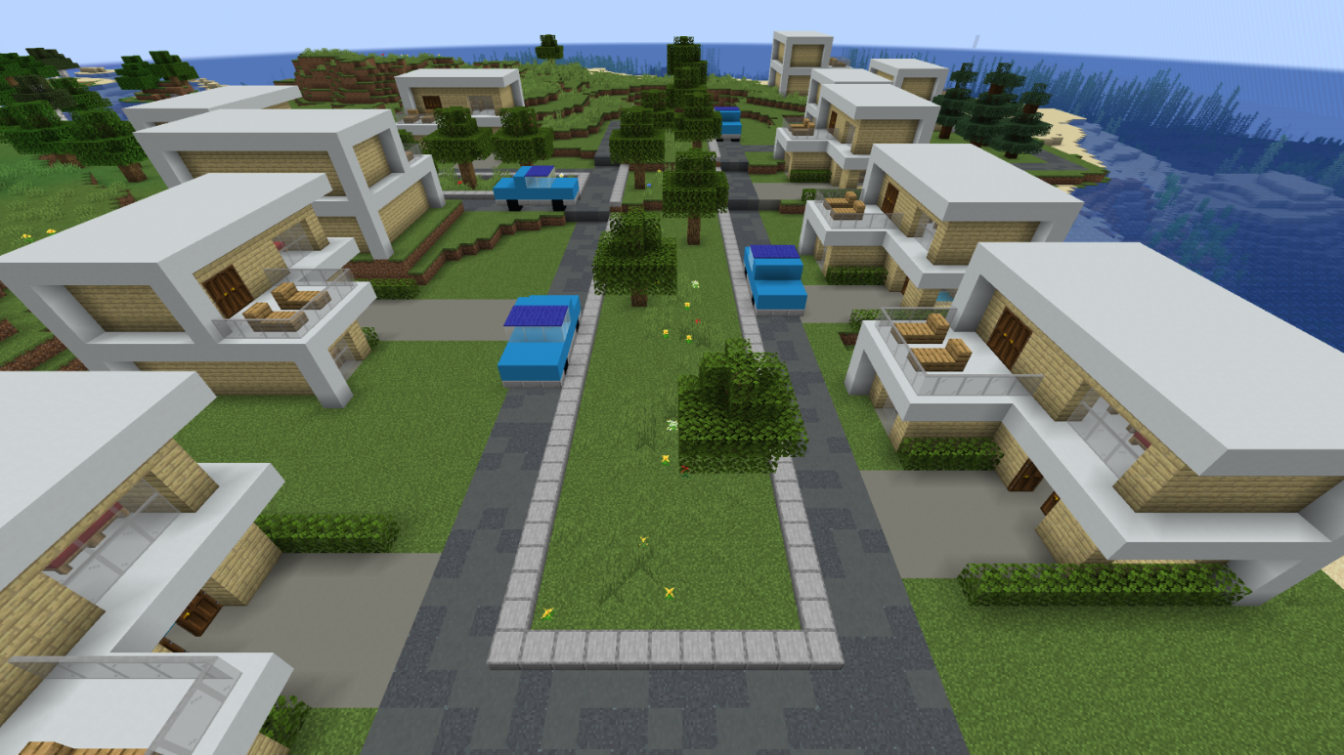
The world will start with the sea being at normal level, as shown in the picture. The water level will rise during the project and always 1 block level at a time (the teacher will do this through specific codes). At its highest, the water level will be 4 blocks higher than in the beginning. You can find a 4-block high measuring stick at the beach to help you visualize.
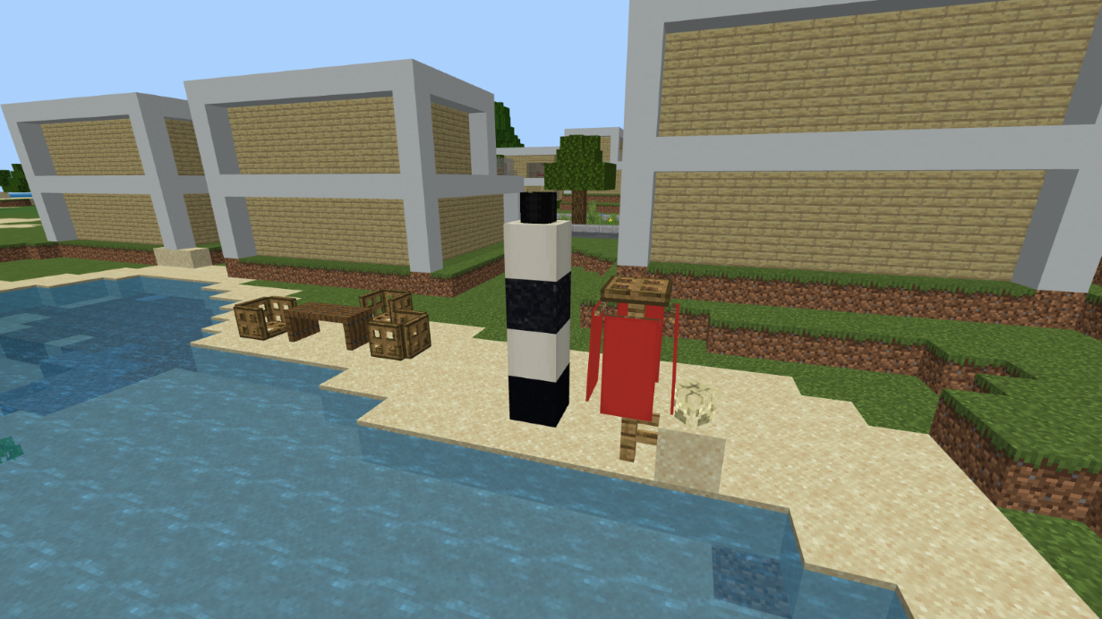
How to play
A separate guide will help you with installing the game on your computer and joining the game server.

Once you are in the game on the Excalibur server, open text chat with T and write the following: /warp tsunami
After that, press Enter and you will be transported to the correct game world.
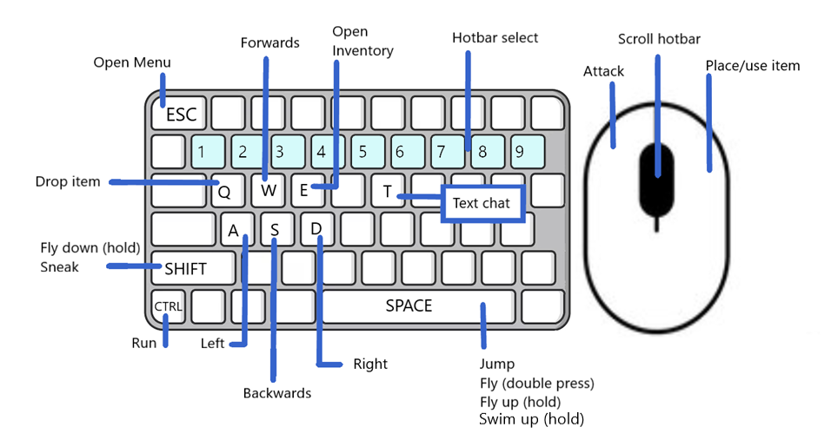

Once inside the game, use the W, A, S, D buttons to move and the mouse to look around. Press the space key to jump.
By pressing E, you can open your inventory: here you can find all sorts of materials for building. When you click on a material, you can move it to the bar on the lower side of the screen: when playing, you can access the materials in this row quickly without opening the inventory again. This row is called the hotbar, and you can go through its contents using the number keys or the mouse scroll.
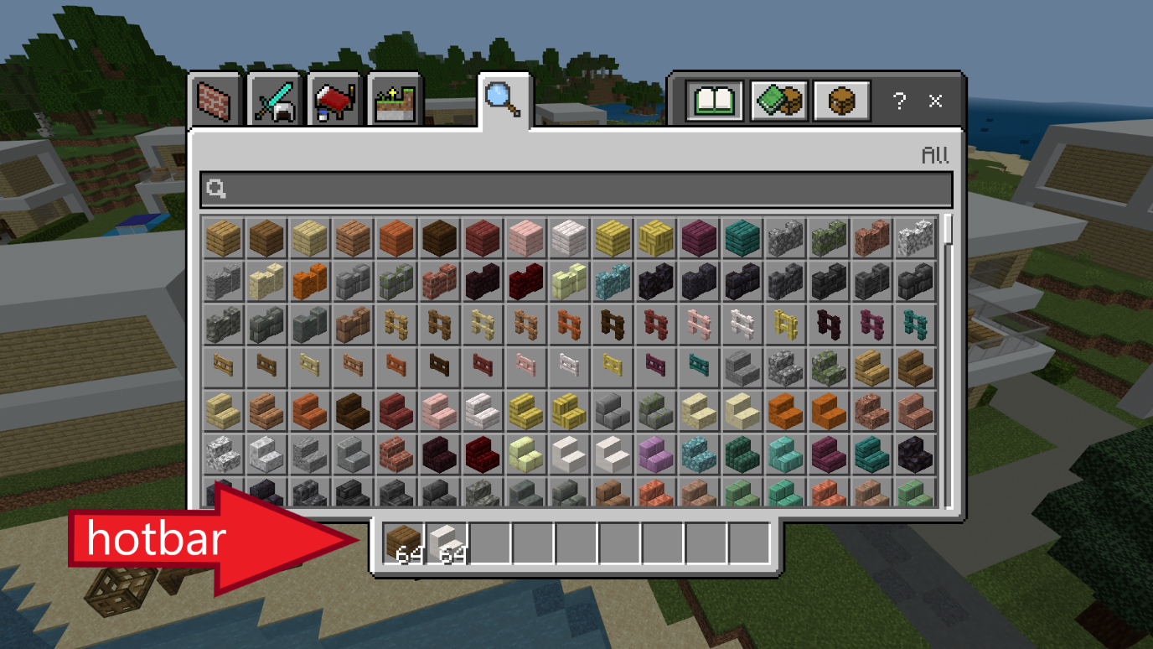
You can destroy blocks with the left-side button on your mouse, and place blocks using the right-side button. When holding a block in your hand, you can drop it to the ground with Q, for example for others to pick it up. To collect a block from the ground, just walk towards it.
Open the text chat with T and press Enter to send your messages.
In this world you are also able to fly. To activate flight mode, press the jumping button (space key) two times quickly. By holding the space key after this, you can rise higher. Going lower happens from holding the shift key. Quickly pressing the space key twice will deactivate the flight mode. If you fall in the water, holding the space key will also let you swim upwards.

5. Rules

1. Don't share the world address with any outsiders, nor the Minecraft account information (that you get from your teacher) with anyone else.
2. Behave responsibly and in accordance with your school rules. Don’t destroy buildings built by other participants! Don’t disturb, harm or grief others or their building work.
3. Don't offend or insult anybody on purpose.
4. We are here to learn and grow together so make the experience enjoyable for everybody involved.

6. Summary

Your tasks in-game | Your tasks outside of the game
- build sustainable housing for yourself on the island | - research how to build sustainably when combined with rising water levels
- make sure that the housing won’t be affected by water level rising | - at the end, present your work as instructed by your teacher  - self-reflection
- work and discuss together with your group

Controls to the game

7. Help for communicating with others

Vocabulary for “The Flood”

More terms: https://minecraft.fandom.com/wiki/Minecraft_Wiki

You can add more terms/languages as needed!

Raw materials/Nature blocks – Rohstoffe/Naturblöcke
 | English | Deutsch
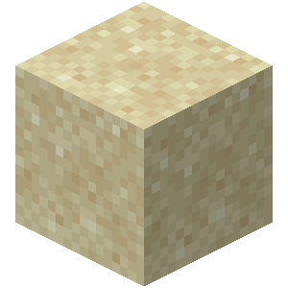 | sand | der Sand
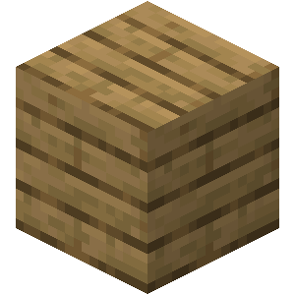 | wood/  planks | das Holz/  die Bretter
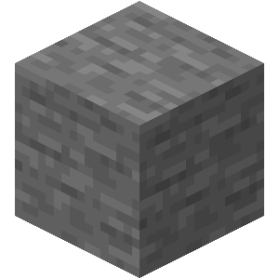 | stone | der Stein
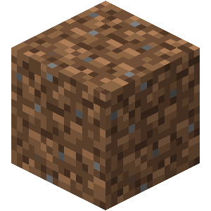 | dirt | die Erde
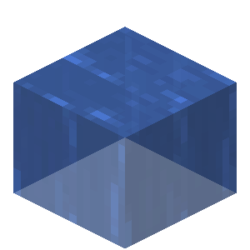 | water | das Wasser

Craftable blocks – Herstellbare Blöcke
 | English | Deutsch
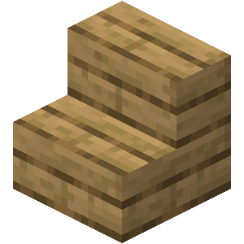 | stairs | die Treppe, die Treppen
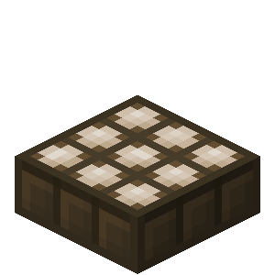 | solar panel, solar panels | das Solarpanel, die Solarpanels
 | glass | das Glas
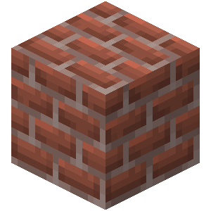 | bricks | die Ziegelsteine

Building verbs – Bauverben
English | Deutsch
dig, dug | graben, gräbt, grub, hat gegraben
mine, mined | ab/bauen, baut ab, baute ab, hat abgebaut
place (a block), placed | stellen, stellt, stellte, hat gestellt  platzieren, platziert, platzierte, hat platziert
build, built | bauen, baut, baute, hat gebaut
destroy, destroyed | zerstören, zerstört, zerstörte, hat zerstört
pile, piled / stack, stacked | stapeln, stapelt, stapelte, hat gestapelt
put, put /  lay, laid, lain | legen, legt, legte, hat gelegt

Other verbs – Andere Verben
English | Deutsch
teleport, teleported | teleportieren, teleportiert, teleportierte, hat teleportiert
fly, flew, flown | fliegen, fliegt, flog, ist geflogen
die, died | sterben, stirbt, starb, ist gestorben
spawn, spawned | spawnen, spawnt, spawnte, ist gespawnt
swim, swam, swum | schwimmen, schwimmt, schwamm, ist geschwommen
jump, jumped | springen, springt, sprang, ist gesprungen
run, ran, run | rennen, rennt, rannte, ist gerannt
rise, rose, risen (water) | steigen, steigt, stieg, ist gestiegen (Wasser)

Phrases – Phrasen
English | Deutsch
Opinion | Meinung
What do you think? | Was denkst du?
In my opinion ... | Nach meiner Meinung ...
I think that ... | Ich glaube, dass ...
Communication | Kommunikation
Could you explain with other words please? | Könntest du bitte mit anderen Worten erklären?
Could you repeat please? | Könntest du bitte wiederholen?
I’ll write/I’m writing in the chat | Ich schreibe in den Chat/im Chat
I don’t understand | Ich verstehe nicht
What are you doing/building? | Was machst/baust du?
Help/Problems | Hilfe/Probleme
Could you help me? | Könntest du mir helfen?
Do you need help with ...? | Brauchst du Hilfe mit ...?
I am stuck, please help | Ich bin stecken geblieben, hilfe bitte
I can’t find ... | Ich finde ... nicht
How can I ... | Wie kann ich ...
How can I build ...? | Wie kann ich ... bauen?
How do I use ...? | Wie benutze ich ...?
How can I find ...? | Wie finde ich ...?

