Teacher guide to "The Bridge”

This is a guide to help you to navigate the Minecraft world “The Bridge”. In this document you will find the following:
1. Quick start – essentials for beginning 1
2. Background story of the world 2
3. Tasks of the teacher 3
4. Learner tasks in the game world 4
5. Learner tasks outside of the game 6
6. Game mechanics and how to play 7
7. Rules for the learners 12
8. Help and materials for communication 13

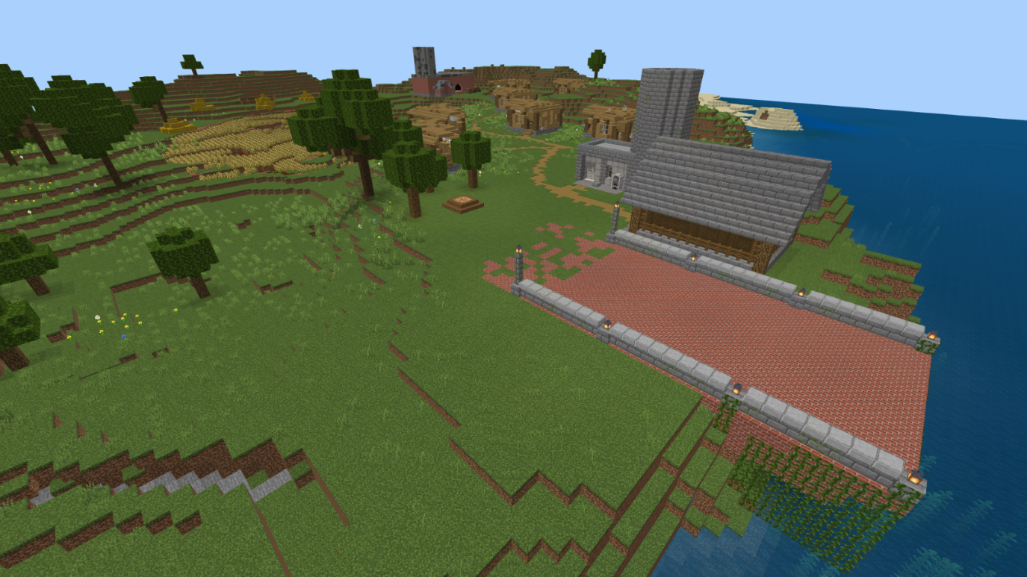
1. Quick start – essentials for beginning

This game world is set on an island, where the connection to the mainland has been severed due to a natural catastrophe caused by climate change. Because of this, the learners will have access only to materials they can find on the island itself. Therefore, they must plan their building work and research different ways of using materials.

Outside of the game, they should present their work in a form of your choice (i.e. presentation, writing assignment, video presentation etc.). They should also self-reflect on their learning on this project.
Your task as the teacher is to present the problem-solving building tasks of the world to the learners. There are 4 objectives in total (detailed in part 4): repairing the bridge, repairing the houses, repurposing the old factory and building a fence for the nature reserve. There are 5 NPCs (non-player characters) who can help the learners by trading certain materials such as solar panels.
You should also provide your learners with linguistic support (when necessary), for which there are support materials in part 8 of this guide. It's also very important and essential to encourage the learners to speak and communicate with each other!
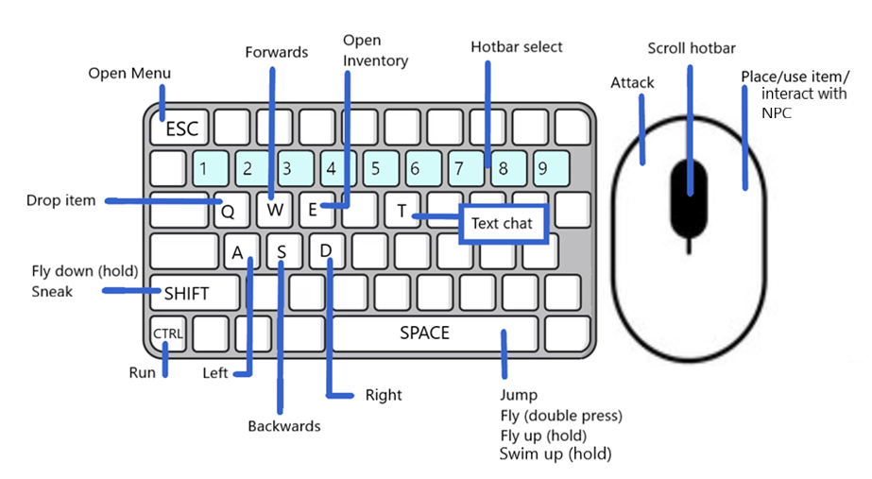
You don’t need to have technical knowledge or know how to play Minecraft. This guide helps with the basics of the game, how to move and build etc.

2. Background story of the world

Welcome to the Minecraft world “The Bridge”! This world consists of an island, which is connected to the mainland by a bridge. The bridge has been broken due to a natural catastrophe caused by climate change. The learners are the inhabitants of the island, and they have to reconnect the two lands. At the moment, they are stuck on the island with no way of reaching the mainland.
The houses on the island are also very old and falling apart, especially due to the natural catastrophe. Additionally, they still contain some asbestos, which is now known to be dangerous. There’s also an old coal factory, not anymore in use but still containing some coal and more asbestos. The learners should repair the houses and consider what to do with the old factory building. The catastrophe has damaged the factory, making it unstable and dangerous.
There had also been plans for converting a part of the island into a protected natural reserve. The conversion project had already been started, but the work was interrupted because of the catastrophe. The protected area now needs to be marked with a fence/border/etc.
Because the island has been disconnected from the mainland, the learners won’t have unlimited materials at their disposal. This means that everything they use for building has to be found on the island. They should therefore make a good plan and see what kind of materials there are to be found.

3. Tasks of the teacher

At the beginning of the first game project lesson, the learners need to be divided into groups. The groups are recommended to be formed in a way that ensures there is at least one person in each group who already has experience of playing Minecraft (if possible). For the purpose of this project, it’s also strongly recommended to combine learners’ different strengths in order to build diverse groups. See the attached group dynamic material for details.
The learners will need the learner guide detailing the scenario’s background story, rules and overall tasks.
Additionally, you should also provide your learners with linguistic support (when necessary), for which there are support materials in part 8 of this guide. It's also very important and essential to encourage the learners to speak and communicate with each other!

4. Learner tasks in the game world
This scenario has learners completing 4 different tasks on the island to complete a larger goal. The main goal of this scenario is to enable teamwork and encourage learners to communicate in-game to better accomplish the given tasks.
- The island's main bridge to the mainland has broken and the learners are tasked with repairing it. The reparation of the bridge can be accomplished in a variety of ways, with the simplest being by connecting the two broken down foundations with a flat bridge made out of bricks. More advanced constructions are of course encouraged. The learners are given a map of the island, which shows the different materials they can find on the island. The students may use any materials that they want for this building process. The island holds a large clay deposit, which can be mined and exchanged for bricks by an NPC (non-player character) by the bridge area. However, the learners should consider what materials make sense for building a bridge (for example, a bridge built from hay is probably not very strong nor fireproof).

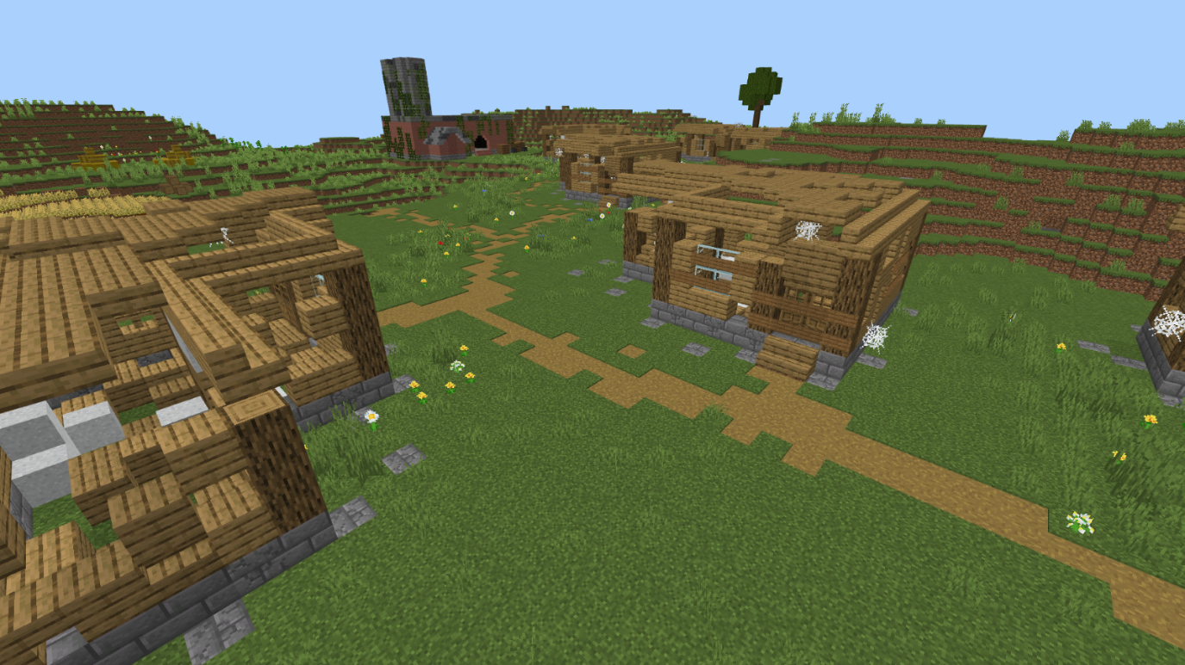
- Due to the natural catastrophe the houses on the island have broken. The learners are tasked with removing the white asbestos found inside the houses and repairing them at least to a usable degree. This can be accomplished with materials they can find on the island. The asbestos is disposed of by mining it and giving it to an NPC by the bridge area.

- An old factory lies on the island, and it is being repurposed for another role. It is filled with coal and asbestos and the students are tasked with removing these materials and bringing them to an NPC by the bridge area, who will dispose of the asbestos safely and responsibly. When the learners trade asbestos and coal with the NPC, they will receive money that they can use to get solar panels for improving the island. They can place these solar panels, i.e. on the roof of the factory, and if they want to, they can build a whole solar farm.

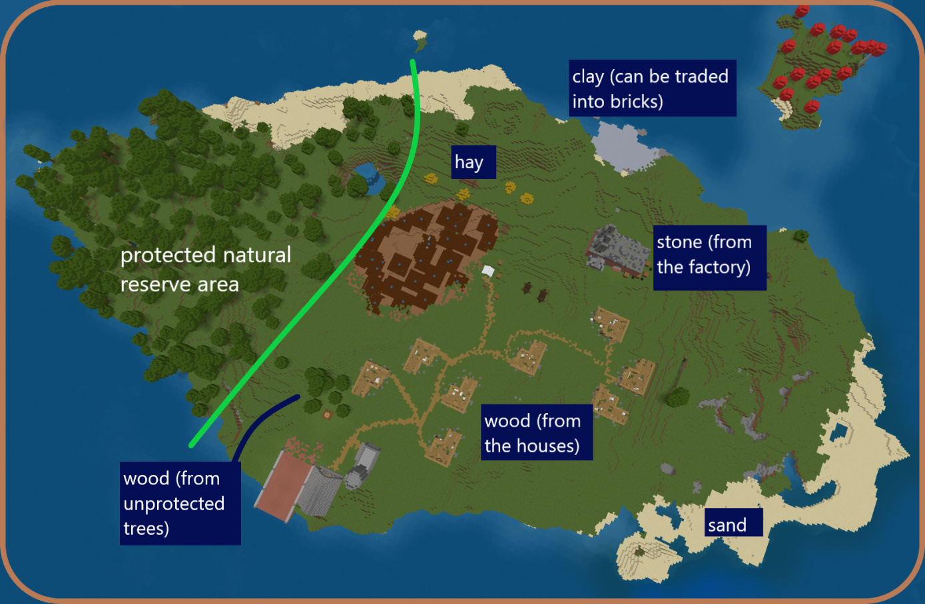
- The learners are given a map of the island, which shows the different materials they can find on the island. There’s also a green line drawn on the map: this shows the border for the planned nature reserve. They should build a fence/border/etc. to mark this line in the game world (as accurately as they can). Note that since the trees behind the line are protected, the learners aren’t allowed to cut them down. There are some trees on the other side of the line, these can be used as material. In the map there are also marked possible materials and where to find them. It is also possible to dig the ground for dirt and stone, but this might not necessarily be the most sustainable solution.

5. Learner tasks outside of the game

While researching and building, the learners are encouraged to recycle old buildings and structures as much as possible and to be creative with the materials they find. They should discuss the challenges and different solutions together with their group and try to decide what kind of solutions would be best in the long run. What materials might be useful for building? What can they make of things they find? They should also research real-life use cases for possible solutions online.
For the planning a shared document is recommended to be used, such as:
- a shared Office Word or Only Office document
- an Etherpad-document (e.g. muistio by Tieke in Finland)
- a CryptPad-document

At the end of the project, the learners should ideally also present their thoughts and findings. You (as the teacher) should give them details on whether it’s, for example, in the form of a group presentation or a personal or a collaboratively written group essay. It could even be a video project. Additionally, they should also reflect on their own learning: What did they learn? Was this type of project useful for them? How did they feel about working with others on this topic?

6. Game mechanics and how to play

In this world the learners won’t have an unlimited inventory of materials. Instead, everything they use must be found in the world. They will be given tools to make digging and mining quicker.

There are altogether 3 NPCs (non-player characters) by the bridge area who can trade certain materials. After the learners reach the mainland, they will unlock new merchants and materials.
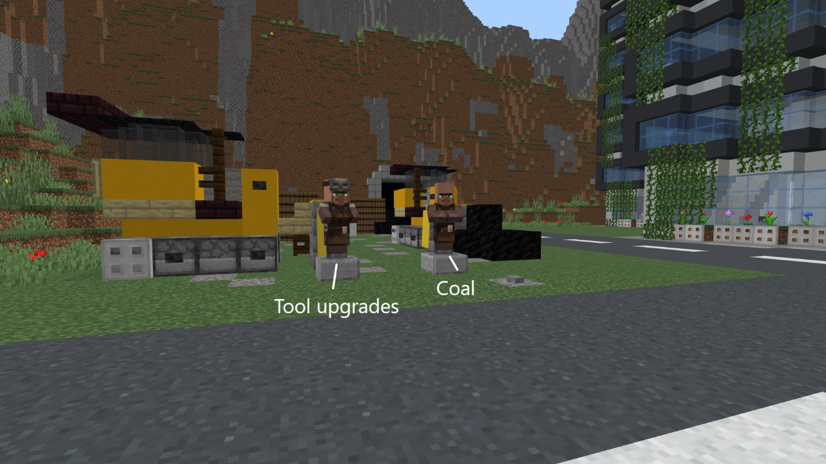
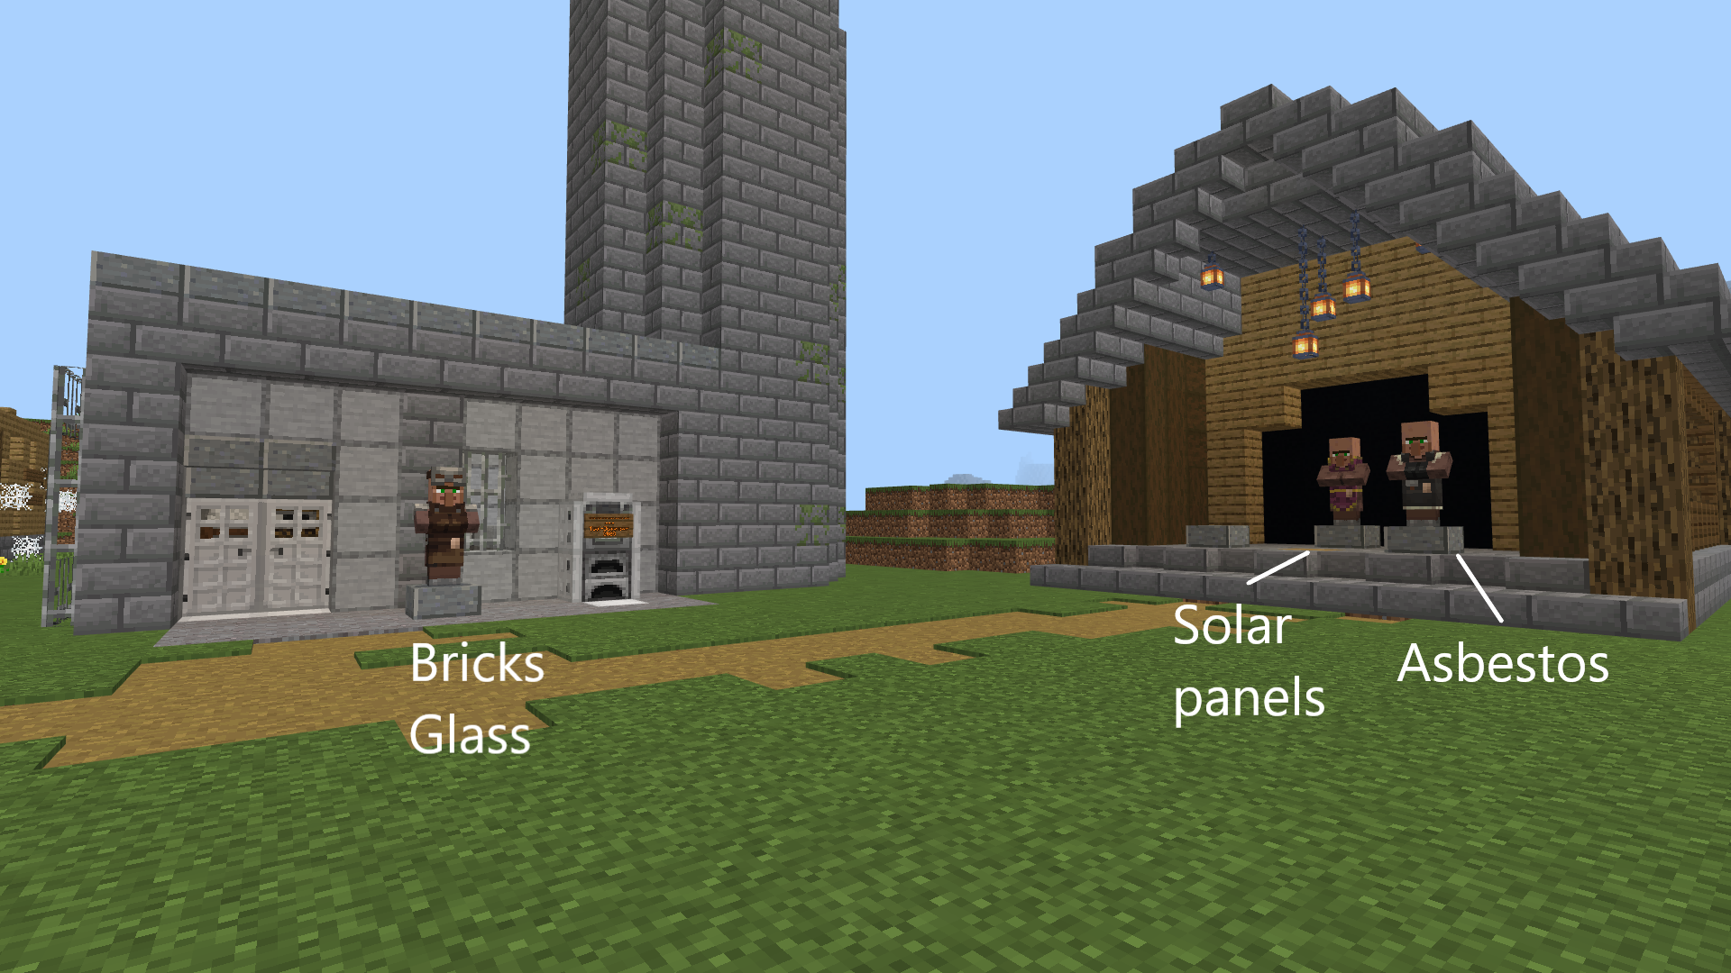

How to play
A separate guide will help you with installing the game on your computer and joining the game server.
Once you are in the game on the Excalibur server, open text chat with T and write the following: /warp two_islands
After that, press Enter and you will be transported to the correct game world.
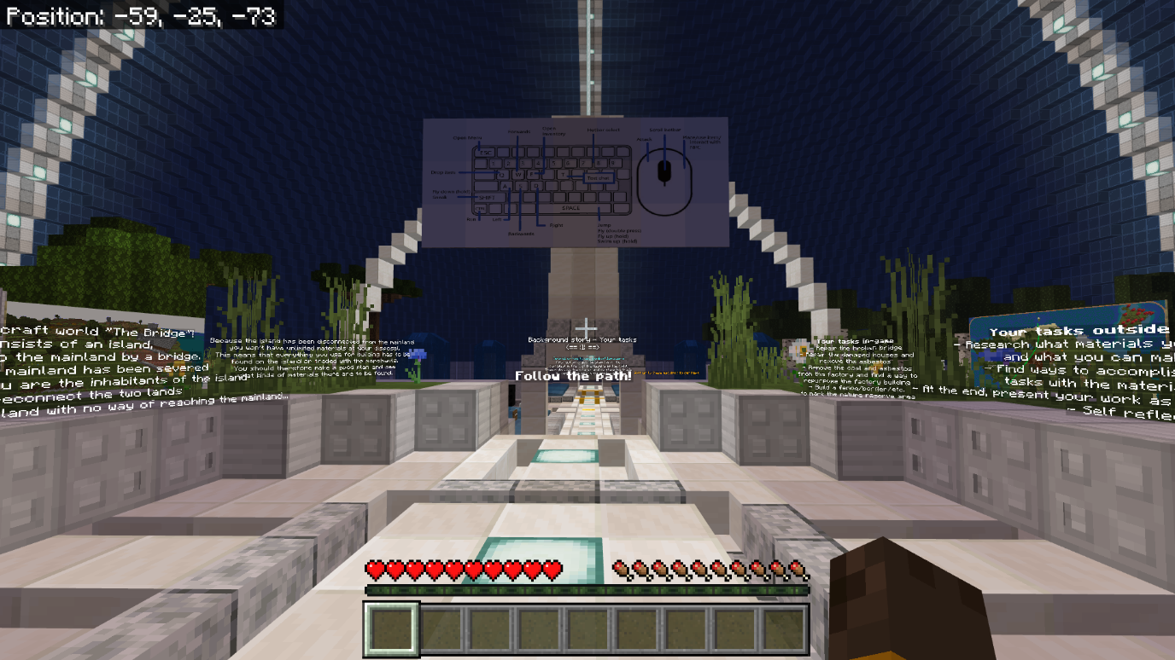
Once inside, you will first be guided through a small tutorial.

You can use the W, A, S, D buttons to move and the mouse to look around. Press the space key to jump.
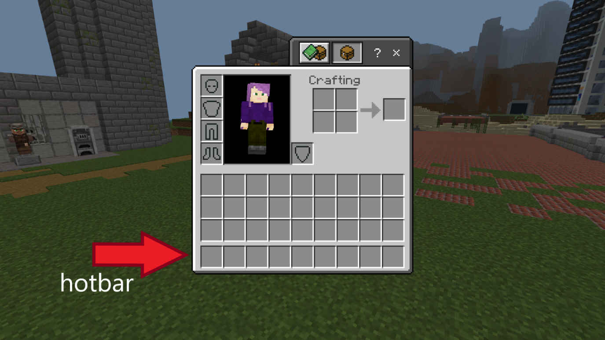
By pressing E, you can open your inventory. When you find a material, it will be added automatically to the lowermost row on the screen. This row is called the hotbar, and you can go through its contents using the number keys or the mouse scroll. When playing, you can access the materials in this row quickly without opening the inventory again. If your hotbar is full when you pick something up, new materials will be added to the upper inventory space, and you will need to open the inventory to access them.

You can destroy blocks with the left-side button on your mouse, and place blocks or trade with the NPCs using the right-side button. When holding a block in your hand, you can drop it to the ground with Q, for example for others to pick it up. To collect a block from the ground, just walk towards it.
Open the text chat with T and press Enter to send your messages.
In this world you are also able to fly. To activate flight mode, press the jumping button (space key) two times quickly. By holding the space key after this, you can rise higher. Going lower happens from holding the shift key. Quickly pressing the space key twice will deactivate the flight mode. If you fall in the water, holding the space key will also let you swim upwards.
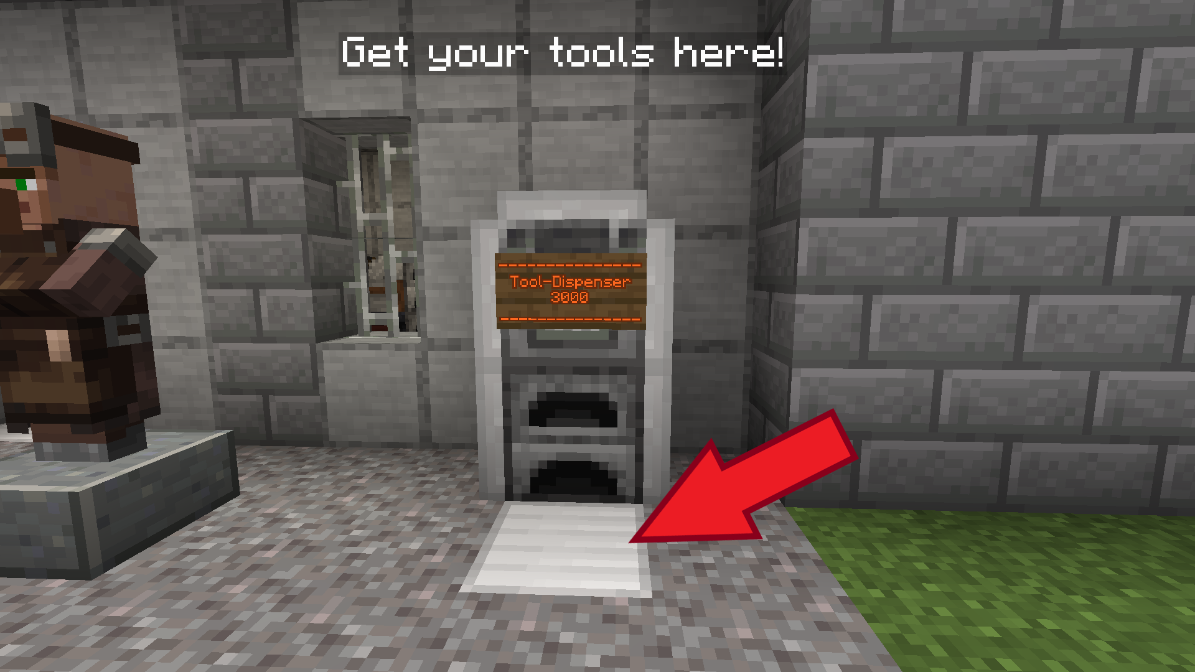
The mainland cannot be reached by flying.

You can destroy blocks faster using tools. You can obtain tools by the bridge area (picture above). Step on the gray plate and a set of tools will be added to your inventory, containing: an axe, a pickaxe, a shovel, a sword and a book of tasks. The book will have a short summary of your tasks, you can read it at any time by right clicking the book when it’s in your currently active hotbar slot.
After reaching the mainland, you can buy faster tools from a merchant. Different tools work better on different materials:
Tool | Shovel | Sword | Pickaxe | Axe
Works best on | Dirt, sand, asbestos, clay | Cobwebs | Stone, metal | Wood

Trading
When you want to trade materials with the merchants, go to one and right-click them. It will open a trading screen, see the picture below.
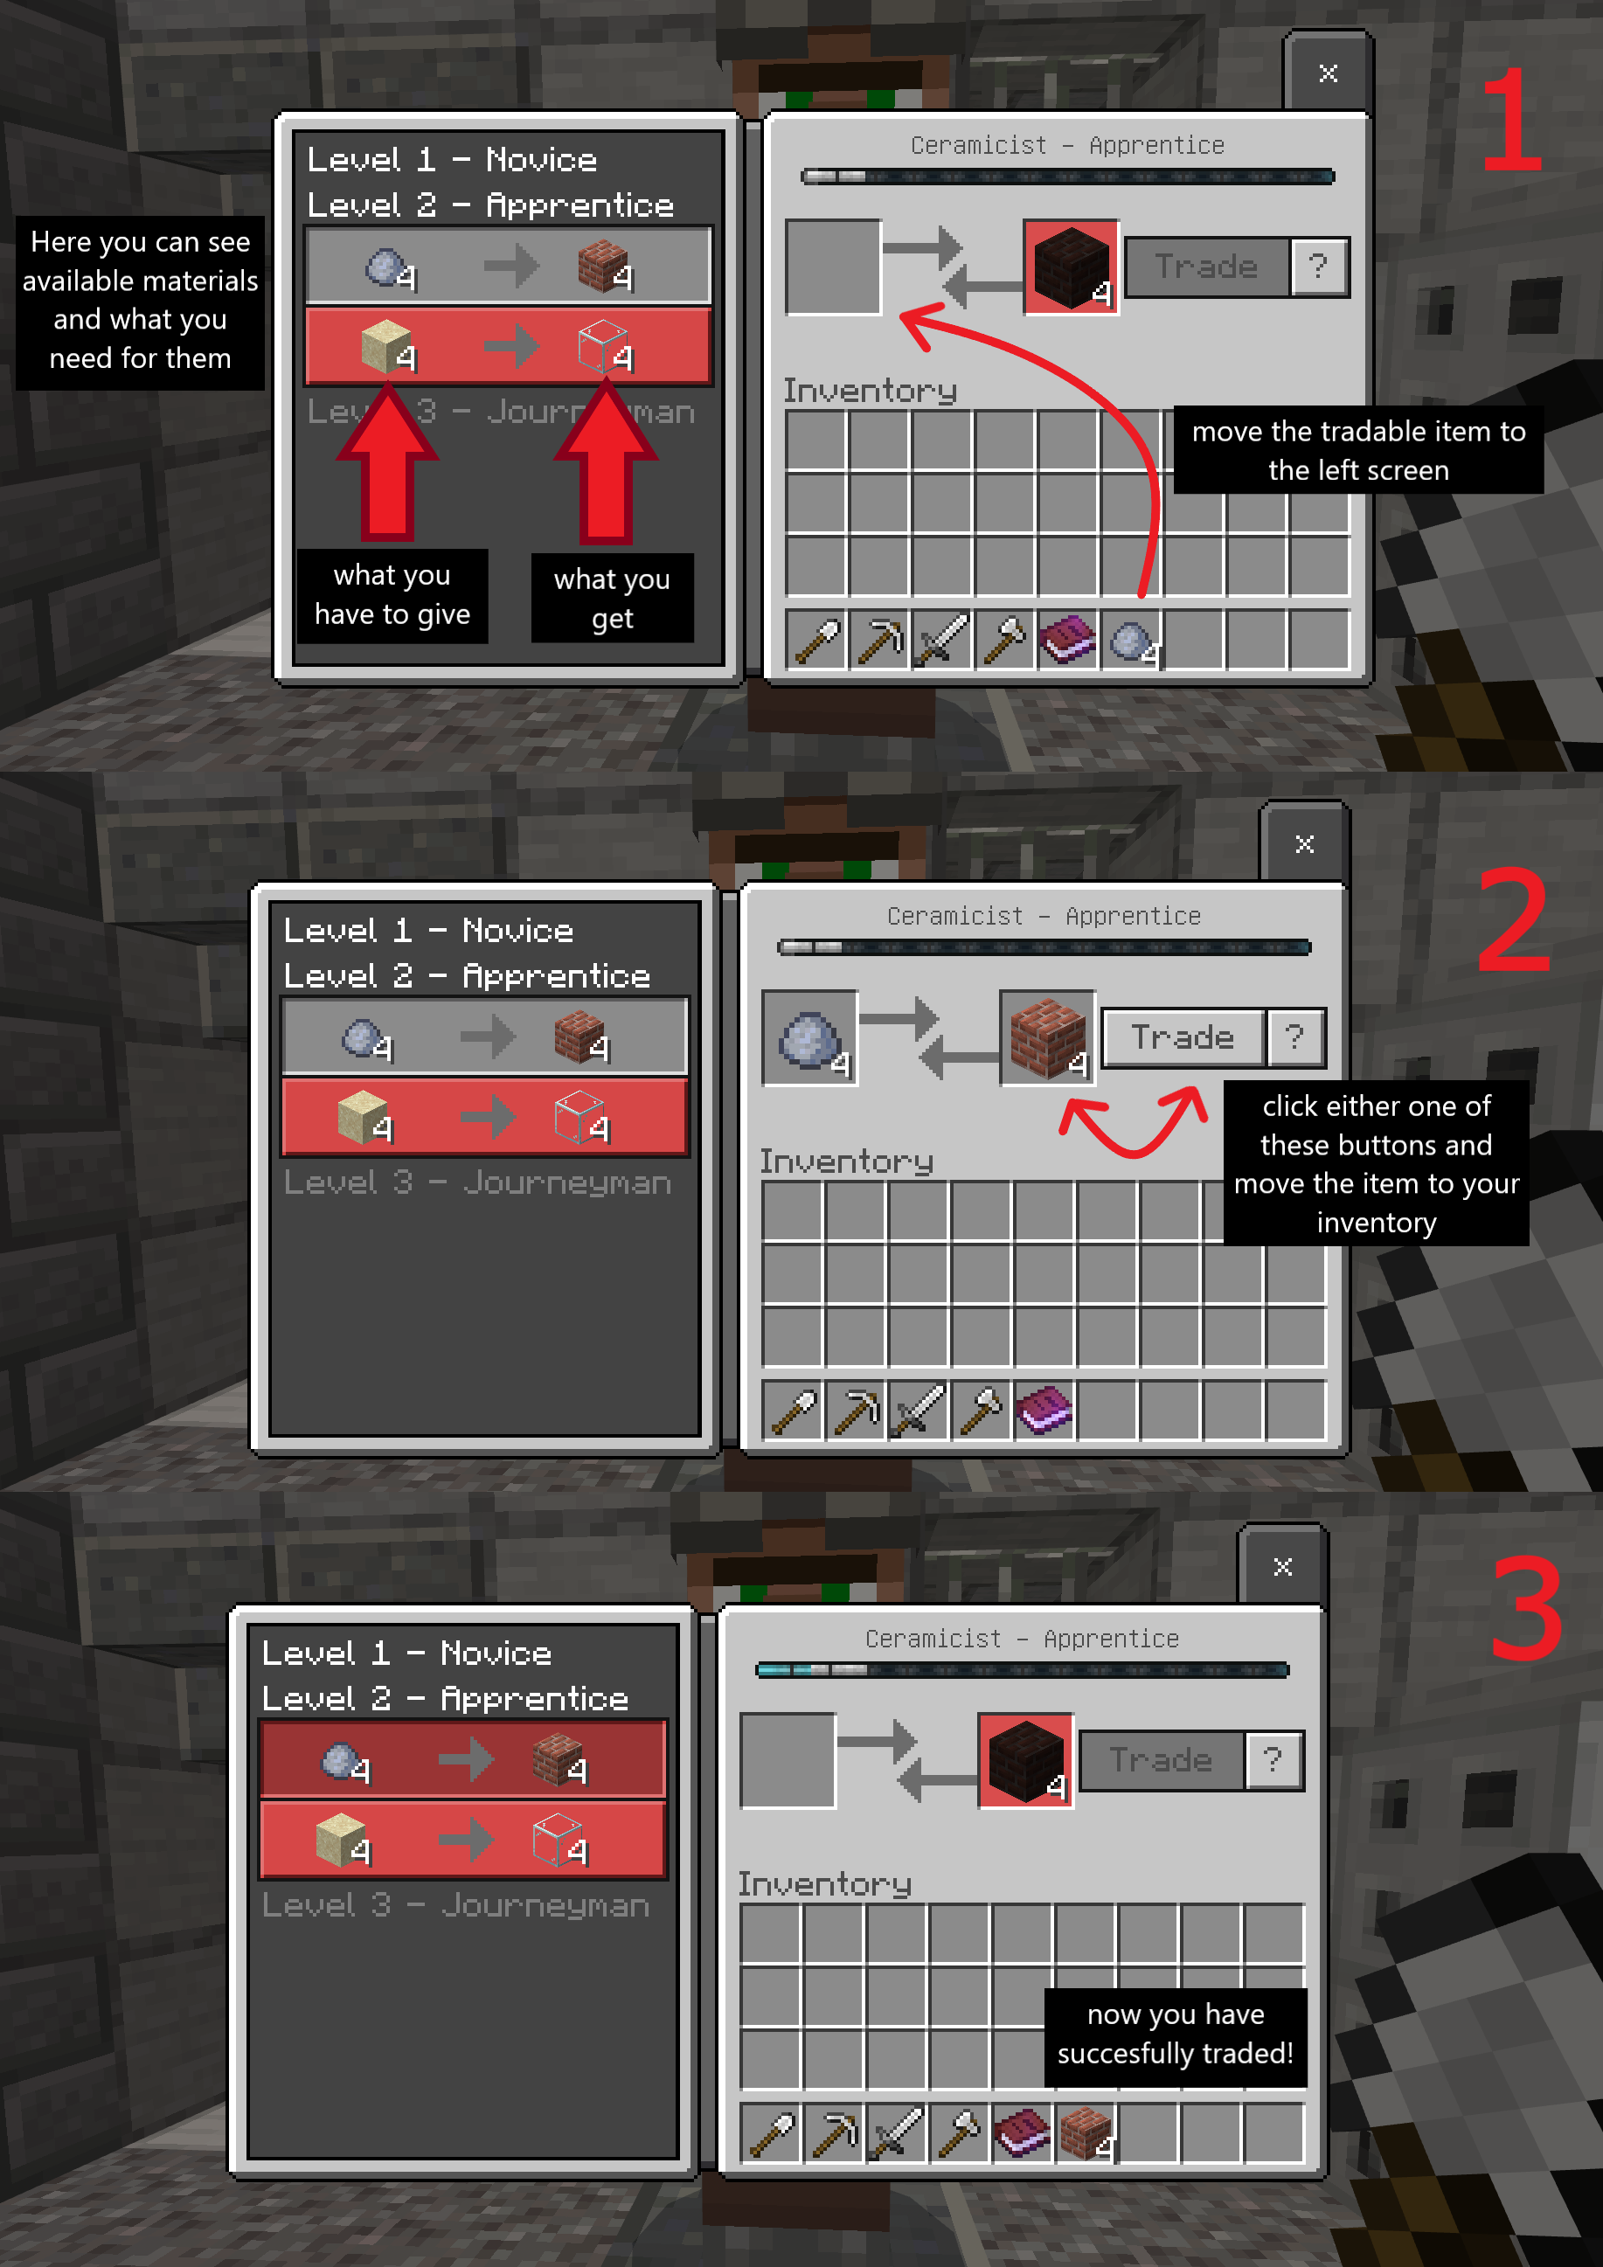

7. Rules for the learners

1. Don't share the world address with any outsiders, nor the Minecraft account information (that you get from your teacher) with anyone else.
2. Behave responsibly and in accordance with your school rules. Don’t destroy buildings built by other participants! Don’t disturb, harm or grief others or their building work.
3. Don't offend or insult anybody on purpose.
4. We are here to learn and grow together so make the experience enjoyable for everybody involved.

8. Help and materials for communication

Vocabulary for “The Bridge”
More terms: https://minecraft.fandom.com/wiki/Minecraft_Wiki

You can add more terms/languages as needed!

Tools – Werkzeuge
 | English | Deutsch
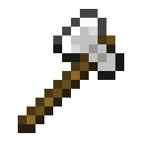 | an axe, axes | die Axt, die Äxte
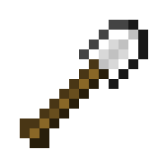 | a shovel, shovels | die Schaufel, die Schaufeln
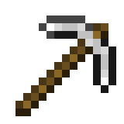 | a pickaxe, pickaxes | die Spitzhacke, die Spitzhacken
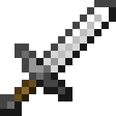 | a sword, swords | das Schwert, die Schwerter

Raw materials/Nature blocks – Rohstoffe/Naturblöcke
 | English | Deutsch
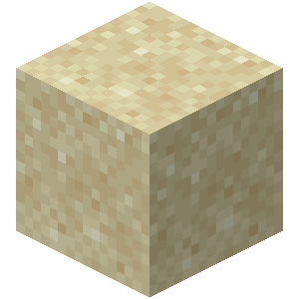 | sand | der Sand
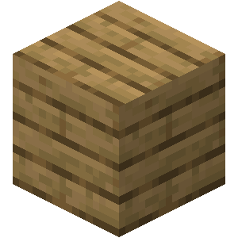 | wood/  planks | das Holz/  die Bretter
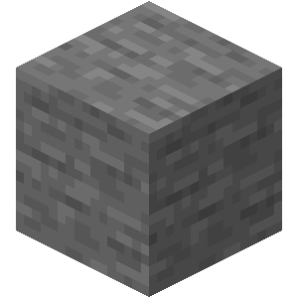 | stone | der Stein
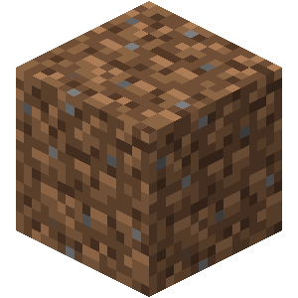 | dirt | die Erde
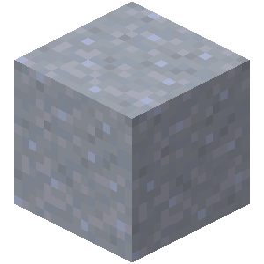 | clay | der Ton
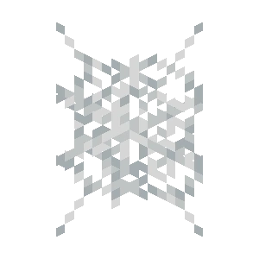 | cobweb | das Spinnennetz
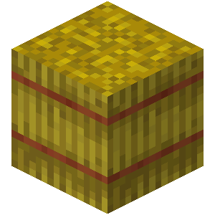 | hay bale | der Strohballen

Craftable/Tradable blocks – Herstellbare/Handelbare Blöcke
 | English | Deutsch
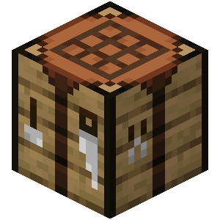 | a crafting table | die Werkbank, die Werkbänke
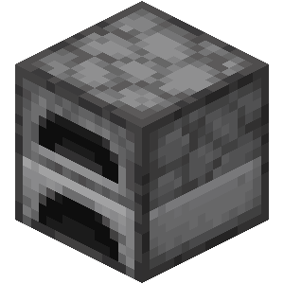 | a furnace | der Ofen, die Öfen
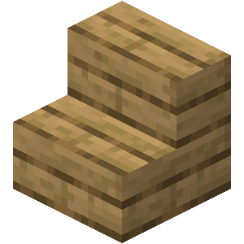 | stairs | die Treppe, die Treppen
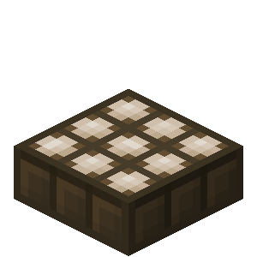 | solar panel, solar panels | das Solarpanel, die Solarpanels
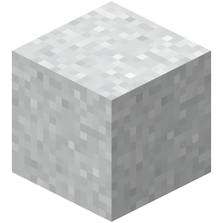 | asbestos | der Asbest
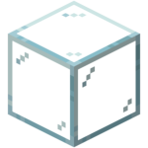 | glass | das Glas
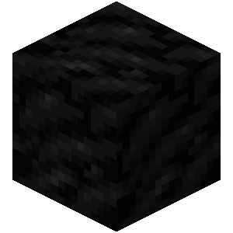 | coal | die Kohle
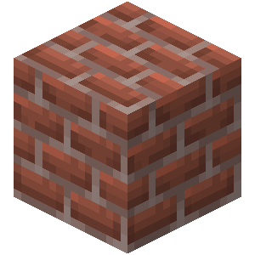 | bricks | die Ziegelsteine

Building verbs – Bauverben
English | Deutsch
dig, dug | graben, gräbt, grub, hat gegraben
mine, mined | ab/bauen, baut ab, baute ab, hat abgebaut
place (a block), placed | stellen, stellt, stellte, hat gestellt /  platzieren, platziert, platzierte, hat platziert
build, built | bauen, baut, baute, hat gebaut
destroy, destroyed | zerstören, zerstört, zerstörte, hat zerstört
pile, piled / stack, stacked | stapeln, stapelt, stapelte, hat gestapelt
put, put /  lay, laid, lain | legen, legt, legte, hat gelegt

Other verbs – Andere Verben
English | Deutsch
teleport, teleported | teleportieren, teleportiert, teleportierte, hat teleportiert
fly, flew, flown | fliegen, fliegt, flog, ist geflogen
die, died | sterben, stirbt, starb, ist gestorben
spawn, spawned | spawnen, spawnt, spawnte, ist gespawnt
swim, swam, swum | schwimmen, schwimmt, schwamm, ist geschwommen
jump, jumped | springen, springt, sprang, ist gesprungen
run, ran, run | rennen, rennt, rannte, ist gerannt
trade, traded | handeln, handelt, handelte, hat gehandelt
exchange X for Y, exchanged | X gegen Y tauschen, tauscht, tauschte, hat getauscht

Phrases – Phrasen
English | Deutsch
Opinion | Meinung
What do you think? | Was denkst du?
In my opinion ... | Nach meiner Meinung ...
I think that ... | Ich glaube, dass ...
Communication | Kommunikation
Could you explain with other words please? | Könntest du bitte mit anderen Worten erklären?
Could you repeat please? | Könntest du bitte wiederholen?
I’ll write/I’m writing in the chat | Ich schreibe in den Chat/im Chat
I don’t understand | Ich verstehe nicht
What are you doing/building? | Was machst/baust du?
Help/Problems | Hilfe/Probleme
Could you help me? | Könntest du mir helfen?
Do you need help with ...? | Brauchst du Hilfe mit ...?
I am stuck, please help | Ich bin stecken geblieben, hilfe bitte
I can’t find ... | Ich finde ... nicht
How can I ... | Wie kann ich ...
How can I build ...? | Wie kann ich ... bauen?
How do I use ...? | Wie benutze ich ...?
How can I find ...? | Wie finde ich ...?

