Teacher guide to "The Flood”

This is a guide to help you to navigate the Minecraft world “The Flood”. In this document you will find the following (you can jump to the parts by clicking the title):
1. Quick start – essentials for beginning 1
2. Background story of the world 2
3. Tasks of the teacher 3
4. Learner tasks in the game world 4
5. Learner tasks outside of the game 4
6. Game mechanics and how to play 5
7. Rules for the learners 8
8. Help and materials for communication 9

1. Quick start – essentials for beginning
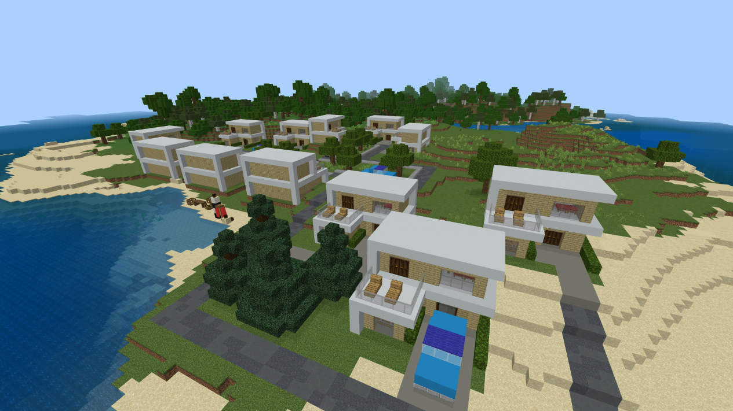

This game world is set on an island, where the learners are threatened by rising sea levels. The water level will actually rise in the game, visualizing in practice the consequences of climate change.

The learners’ task in-game is to design and build sustainable housing for themselves, so that they can continue living on the island. The learners must research how to build houses in such a way that they won’t end up underwater.
Outside of the game, they should present their work in a form of your choice (i.e. presentation, writing assignment, video presentation etc.). They should also self-reflect on their learning on this project.

Your task as the teacher is to regulate the water level in the world. This is done by writing a line of text in the game chat (details in part 3 of this guide). You can choose when you want to raise the water level, depending on how much time you have for this project. You should also provide your learners with linguistic support (when necessary), for which there are support materials in part 8 of this guide. It's also very important and essential to encourage the learners to speak and communicate with each other!

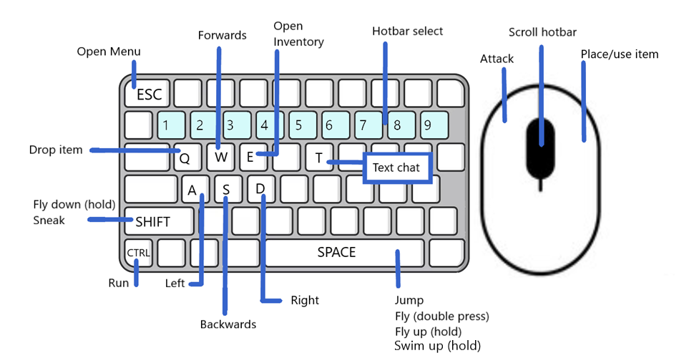
You don’t need to have technical knowledge or know how to play Minecraft. This guide helps with the basics of the game, how to move and build etc.

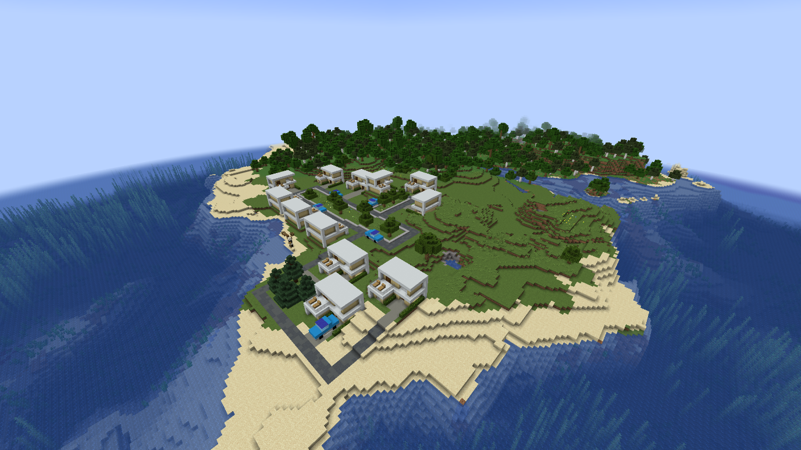
2. Background story of the world

Welcome to the Minecraft world “The Flood”! Here the learners will find themselves living on an island with some houses and a small forest. They have been living on this island for a long time in harmony with their surroundings. However, due to climate change, their lives are threatened by the rise of the sea level. The currents houses aren’t designed to hold water for very long and therefore they are in urgent need of new, ecological housing that will allow them to continue living on the island. They have to work quickly, though, because the sea level can rise at any moment!

3. Tasks of the teacher

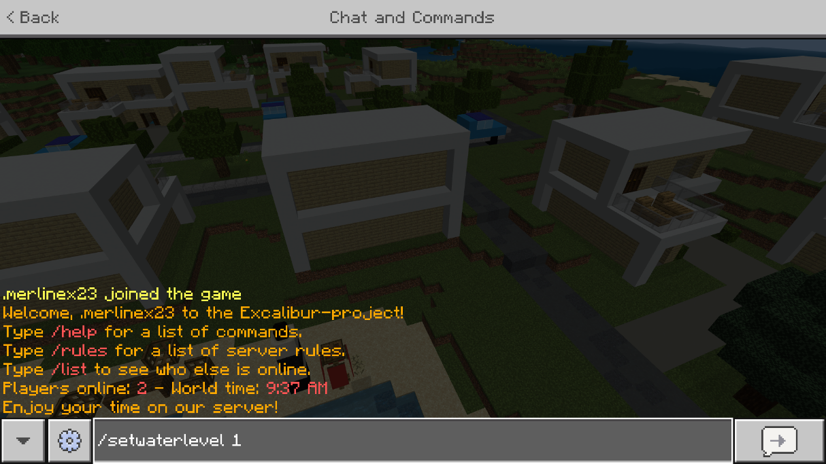
An important task for you is to regulate the water level height in the world. You can choose when you want the level to rise, depending on how much time you have for this project. To raise the water, open the text chat with the T button, type the command “/setwaterlevel“ followed by a space and a number between one (1) and four (4) and press Enter. This will raise the water to the height in blocks specified. For example, if you want to raise the water level to the height of 1 block you would type the command “/setwaterlevel 1”. In total, the water can rise to the height of 4 blocks. The water level can be reset back to the original level with the command “/resetwaterlevel”. When typing the command in the in-game chat, type it without the quotation marks! Remember that all in-game console commands begin with a slash /

You should pay care not to show these water level commands to the students as all in-game players are able to use these two commands. These water level regulating special commands are importantly hidden from the in-game command autocomplete function in order to prevent the students from changing the water level and causing problems for the game. On the recommended newer Minecraft Bedrock edition, the commands’ text will be white, as shown in the picture above. Note: if you use Minecraft Java edition, the commands may show up as red, as in the below picture. They work nonetheless the same.

At the beginning of the first game project lesson, the learners need to be divided into groups. The groups are recommended to be formed in a way that ensures there is at least one person in each group who already has experience of playing Minecraft (if possible). For the purpose of this project, it’s also strongly recommended to combine learners’ different strengths in order to build diverse groups. See the attached group dynamic material for details.
The learners will need the learner guide detailing the scenario’s background story, rules and overall tasks.
Additionally, you should also provide your learners with linguistic support (when necessary), for which there are support materials in part 8 of this guide. It's also very important and essential to encourage the learners to speak and communicate with each other!

4. Learner tasks in the game world

The learners’ task is to build ecological housing for themselves as a group so that they can continue living there. They have to research different types of ecological building materials and techniques and decide what kind of house(s) they want to build. The sea level in the game will rise 4 times in total (in total the height of 4 blocks), so they have to ensure that their buildings don’t end up underwater in the end. The main goal of this scenario is to enable teamwork and encourage learners to communicate in-game to better accomplish the given task.

5. Learner tasks outside of the game

While researching and building, the learners should discuss the challenges and different solutions together with their group and try to decide what kind of solutions would be best in the long run. What if the water level rises even more in the future? They should also research real-life use cases for possible solutions online. For the planning a shared document is recommended to be used.
For example:
- a shared Office Word or Only Office document
- an Etherpad-document (e.g. muistio by Tieke in Finland)
- a CryptPad-document

At the end of the project, the learners will also present their thoughts and findings. You (as the teacher) should give them details on whether it’s, for example, in the form of a group presentation or a personal or a collaboratively written group essay. It could even be a video project. Additionally, they should also reflect on their own learning: What did they learn? Was this type of project useful for them? How did they feel about working with others on this topic?

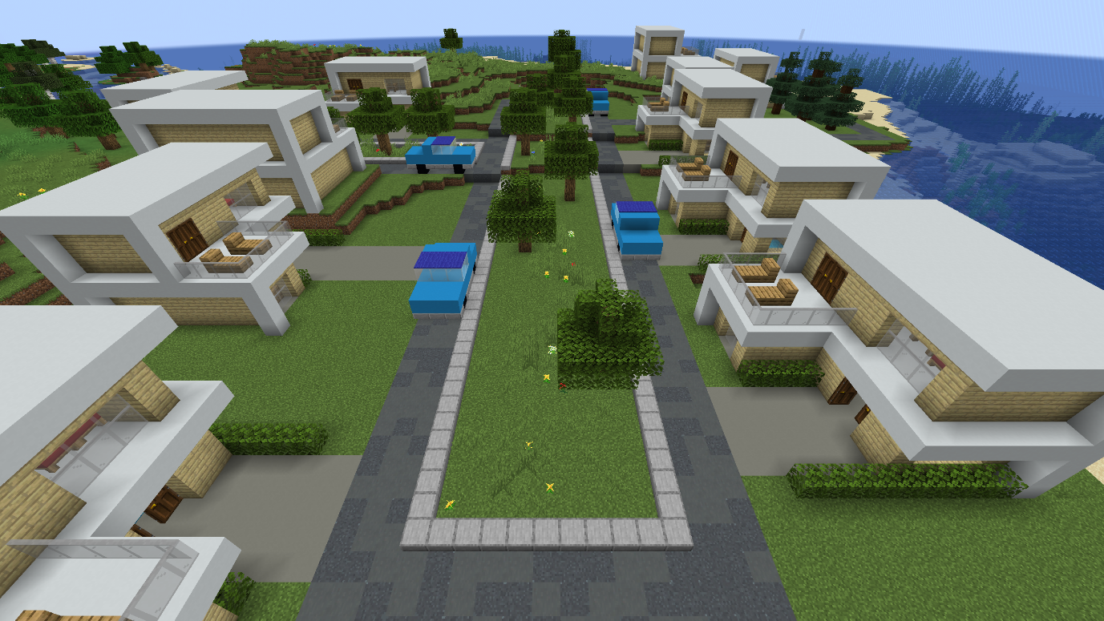
6. Game mechanics and how to play

The world will start with the sea being at normal level, as shown in the picture. The water level will rise during the project and 1 block level at a time (you will do this through specific commands). At its highest, the water level will be 4 blocks higher than in the beginning. You can find a 4-block high black-and-white measuring stick on the beach to help you visualize.
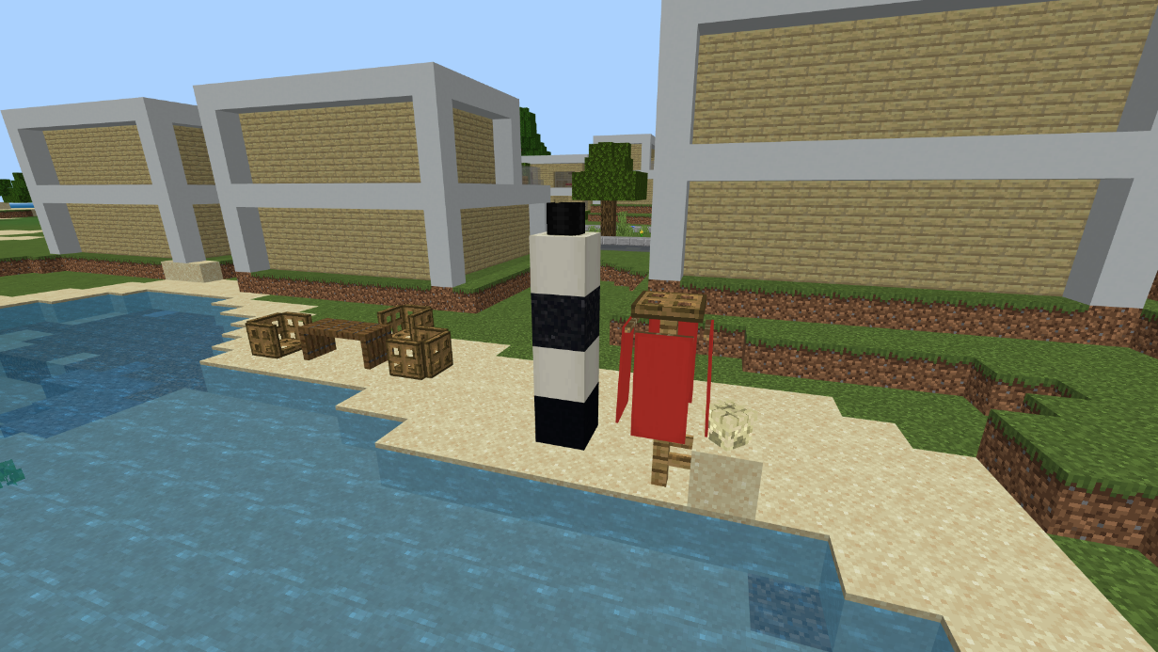

How to play
A separate guide will help you with installing the game on your computer and joining the game server. Once you are in the game on the Excalibur server, open text chat with T and write the following: /warp tsunami
After that, press Enter and you will be transported to the correct game world.
Once inside the game, use the W, A, S, D buttons to move and the mouse to look around. Press the space key to jump.

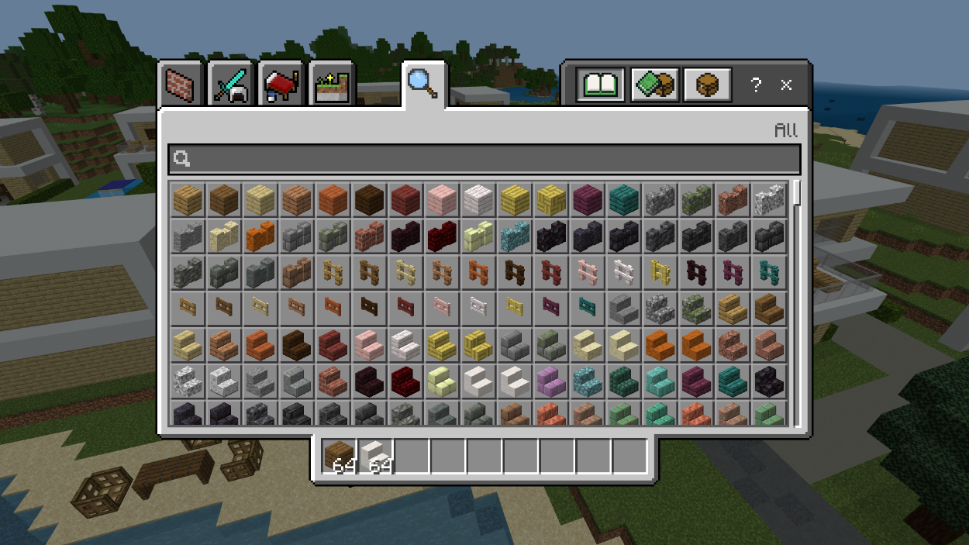
By pressing E, you can open your inventory: here you can find all sorts of materials for building. When you click on a material, you can move it to the bar on the lower side of the screen: when playing, you can access the materials in this row quickly without opening the inventory again. This row is called the hotbar, and you can go through its contents using the number keys or the mouse scroll.

You can destroy blocks with the left-side button on your mouse, and place blocks using the right-side button. When holding a block, you can drop it to the ground with Q, for example for others to pick it up. To collect a block from the ground, just walk towards it.
Open the text chat with T and press Enter to send your messages.
In this world you are also able to fly. To activate flight mode, press the jumping button (space key) two times quickly. By holding the space key after this, you can rise higher. Going lower happens from holding the shift key. Quickly pressing the space key twice will deactivate the flight mode. If you fall in the water, holding the space key will also let you swim upwards.

7. Rules for the learners

1. Don't share the world address with any outsiders, nor the Minecraft account information (that you get from your teacher) with anyone else.
2. Behave responsibly and in accordance with your school rules. Don’t destroy buildings built by other participants! Don’t disturb, harm or grief others or their building work.
3. Don't offend or insult anybody on purpose.
4. We are here to learn and grow together so make the experience enjoyable for everybody involved.

8. Help and materials for communication

Vocabulary for “The Flood”

More terms: https://minecraft.fandom.com/wiki/Minecraft_Wiki

You can add more terms/languages as needed!

Raw materials/Nature blocks – Rohstoffe/Naturblöcke
 | English | Deutsch
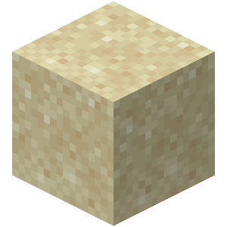 | sand | der Sand
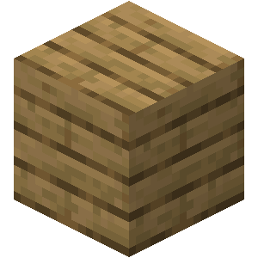 | wood/  planks | das Holz/  die Bretter
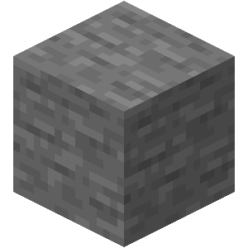 | stone | der Stein
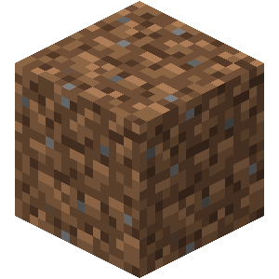 | dirt | die Erde
 | water | das Wasser

Craftable blocks – Herstellbare Blöcke
 | English | Deutsch
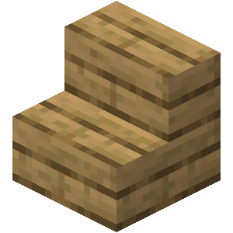 | stairs | die Treppe, die Treppen
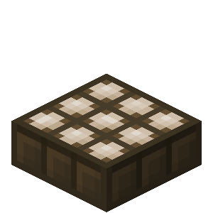 | solar panel, solar panels | das Solarpanel, die Solarpanels
 | glass | das Glas
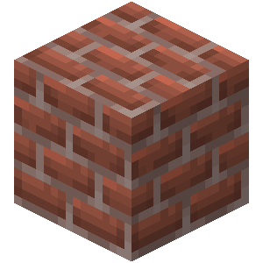 | bricks | die Ziegelsteine

Building verbs – Bauverben
English | Deutsch
dig, dug | graben, gräbt, grub, hat gegraben
mine, mined | ab/bauen, baut ab, baute ab, hat abgebaut
place (a block), placed | stellen, stellt, stellte, hat gestellt  platzieren, platziert, platzierte, hat platziert
build, built | bauen, baut, baute, hat gebaut
destroy, destroyed | zerstören, zerstört, zerstörte, hat zerstört
pile, piled / stack, stacked | stapeln, stapelt, stapelte, hat gestapelt
put, put /  lay, laid, lain | legen, legt, legte, hat gelegt

Other verbs – Andere Verben
English | Deutsch
teleport, teleported | teleportieren, teleportiert, teleportierte, hat teleportiert
fly, flew, flown | fliegen, fliegt, flog, ist geflogen
die, died | sterben, stirbt, starb, ist gestorben
spawn, spawned | spawnen, spawnt, spawnte, ist gespawnt
swim, swam, swum | schwimmen, schwimmt, schwamm, ist geschwommen
jump, jumped | springen, springt, sprang, ist gesprungen
run, ran, run | rennen, rennt, rannte, ist gerannt
rise, rose, risen (water) | steigen, steigt, stieg, ist gestiegen (Wasser)

Phrases – Phrasen
English | Deutsch
Opinion | Meinung
What do you think? | Was denkst du?
In my opinion ... | Nach meiner Meinung ...
I think that ... | Ich glaube, dass ...
Communication | Kommunikation
Could you explain with other words please? | Könntest du bitte mit anderen Worten erklären?
Could you repeat please? | Könntest du bitte wiederholen?
I’ll write/I’m writing in the chat | Ich schreibe in den Chat/im Chat
I don’t understand | Ich verstehe nicht
What are you doing/building? | Was machst/baust du?
Help/Problems | Hilfe/Probleme
Could you help me? | Könntest du mir helfen?
Do you need help with ...? | Brauchst du Hilfe mit ...?
I am stuck, please help | Ich bin stecken geblieben, hilfe bitte
I can’t find ... | Ich finde ... nicht
How can I ... | Wie kann ich ...
How can I build ...? | Wie kann ich ... bauen?
How do I use ...? | Wie benutze ich ...?
How can I find ...? | Wie finde ich ...?

